## CHAPTER 4

### PROJECTIONS OF SOLIDS

Problem 1 A square prism 35 mm sides of base and 65 mm axis length rests on HP on one of its edges of the base

which is inclined to VP at 30a. Draw the projections of the prism when the axis is inclined to HP at 45°.

##### Solution

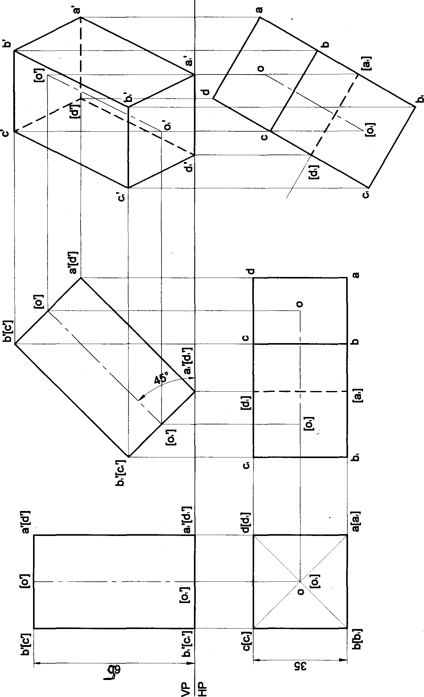

77

Problem 2 A square prism 35 mm sides of base and 60 mm axis length rests on HP on one of its comers of the base such that the two base edges containing the corner on which it rests make equal inclinations with HP. Draw the projections of the prism when the axis of the prism is inclined to HP at 40° and appears to be inclined to VP at 45°. Solution

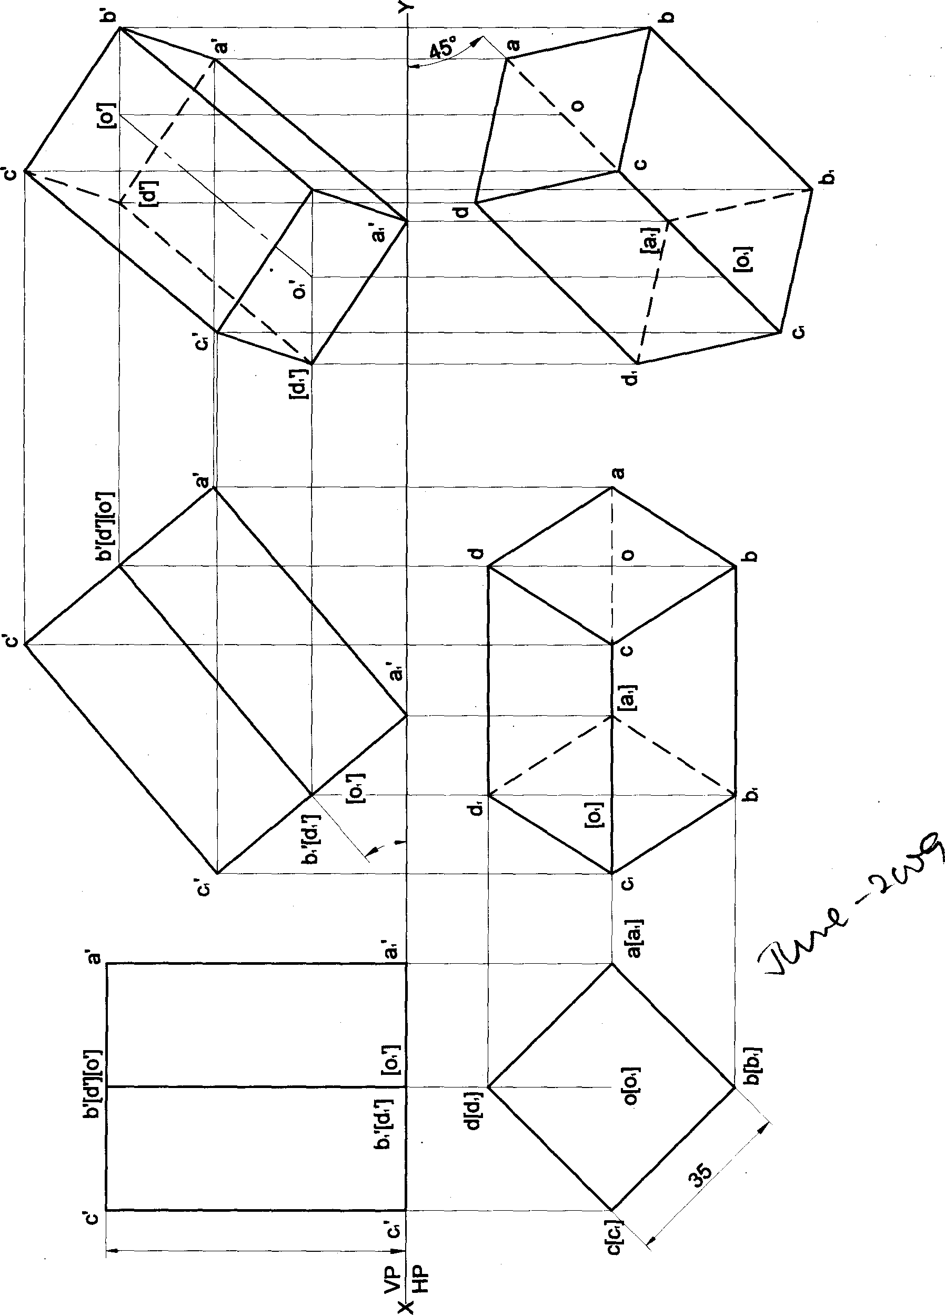

78

Problem 3 A square prism 35 mm sides of base and 60 mm axis length rests on HP on one of its comers of thebase such that the two base edges œntaining the œmer on which it rests make equal inclinations with HP. Dæw the projections of the prism when the axis of the prism is inclined to HP at 40ᵉ and to VP at 3Œ.

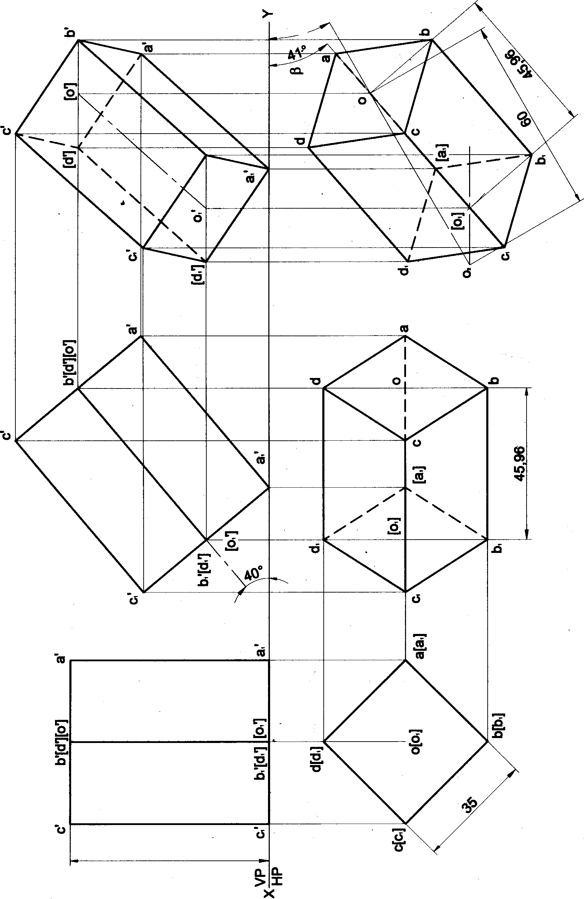Solution

79

Problem 4 A square prism 35 mm Aides of base and 60 mm axis length rests on HP on one of its edges of the base Draw the projections of the prism when the axis is inclined to HP at 45a and VP at 30°.

##### Solution

09

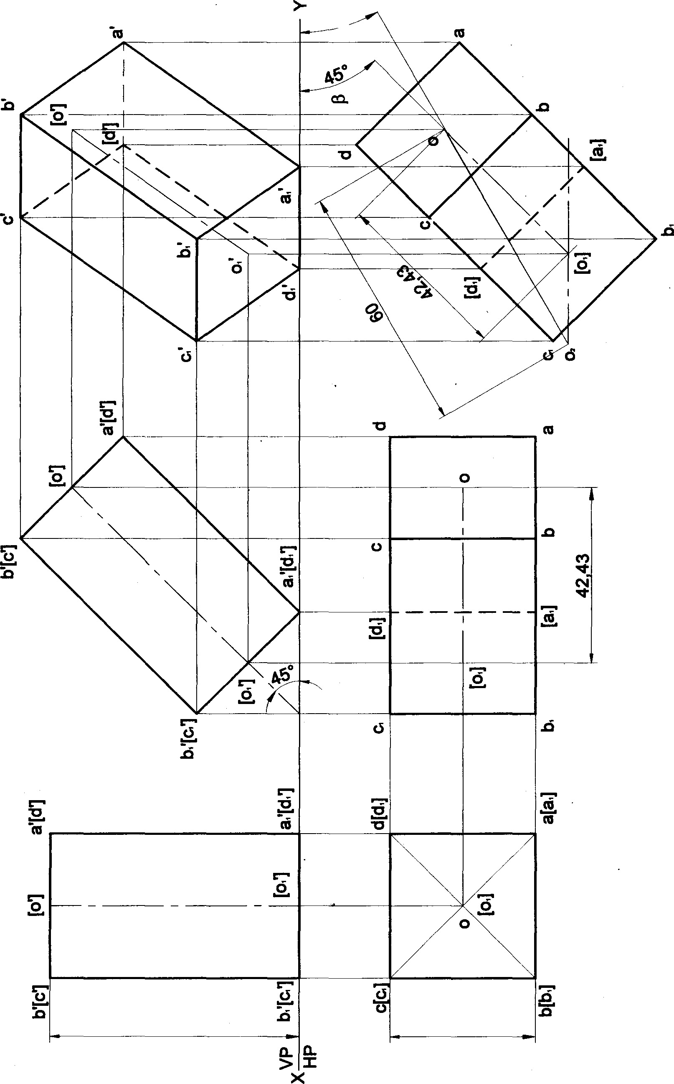

80

Problem 5 A pentagonal prism 25 mm sides of base and 60 mm axis length rests on HP on one of its edges of the base which is inclined to VP at 30a. Draw the projections of the prism when the axis is inclined to HP at 40°.

##### Solution

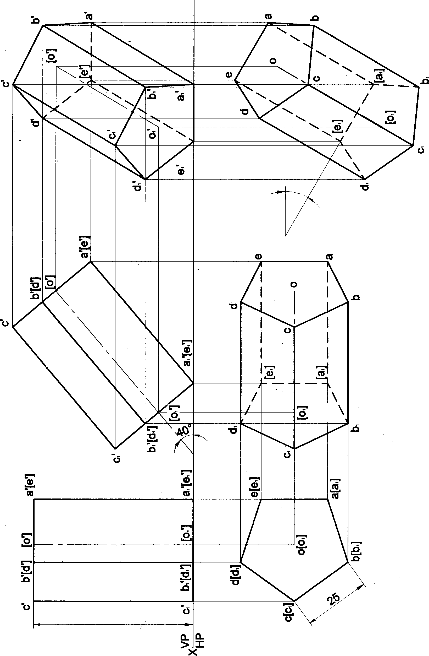

81

Problem 6 A pentagonal prism 25 mm sides of base and 60 mm axis length rests on HP on one of its edges of the base. Draw the projections of the prism when the axis is inclined to HP at 4fP and VP at 3tP.

##### Solution

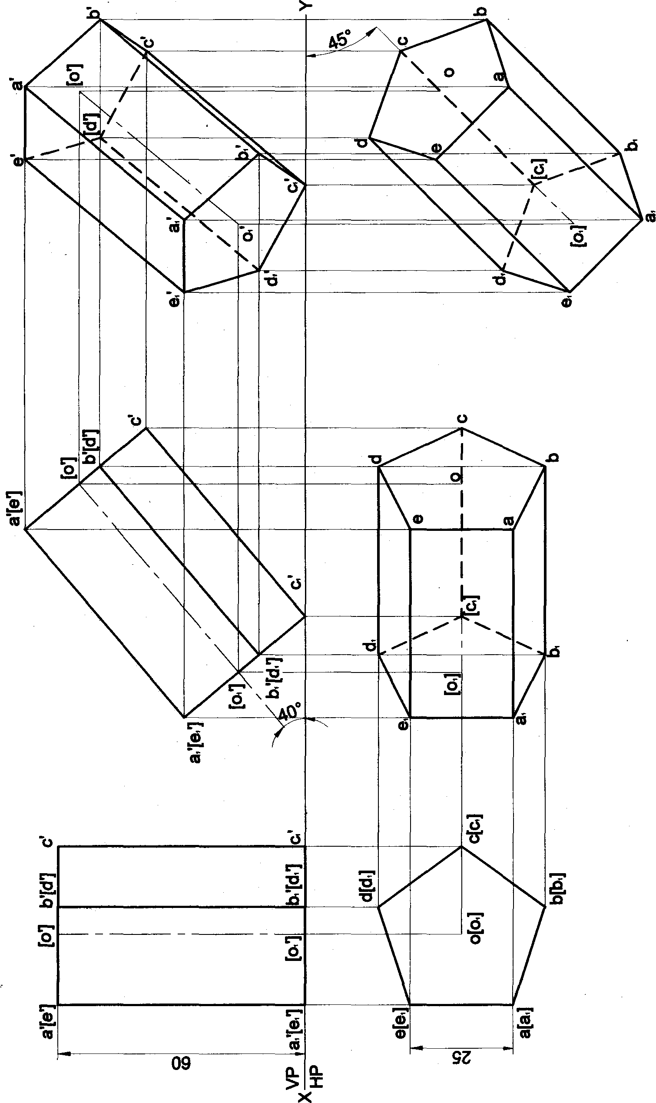/ roblem 7 A pentagonal prism *25* mm sides of base and 50 mm axis length rests on HP on one of its comers of the base such that the two base edges containing the comer on which it rests make equal inclinations with HP. Draw the projections of the prism when the axis of the prism is inclined to HP at 40* and appears to be inclined to VP at 45a. Solution

83



Problem 8 A pentagonal prism 25 mm sides of base and 50 mm axis length rests on HP on one of its corners of tha base such that the two base edges containing the comer on which it rests make equal indinations with HP. Draw tha projections of the prism when the axis of the prism is inclined to HP at 40° and to VP at 30*.

### Solution

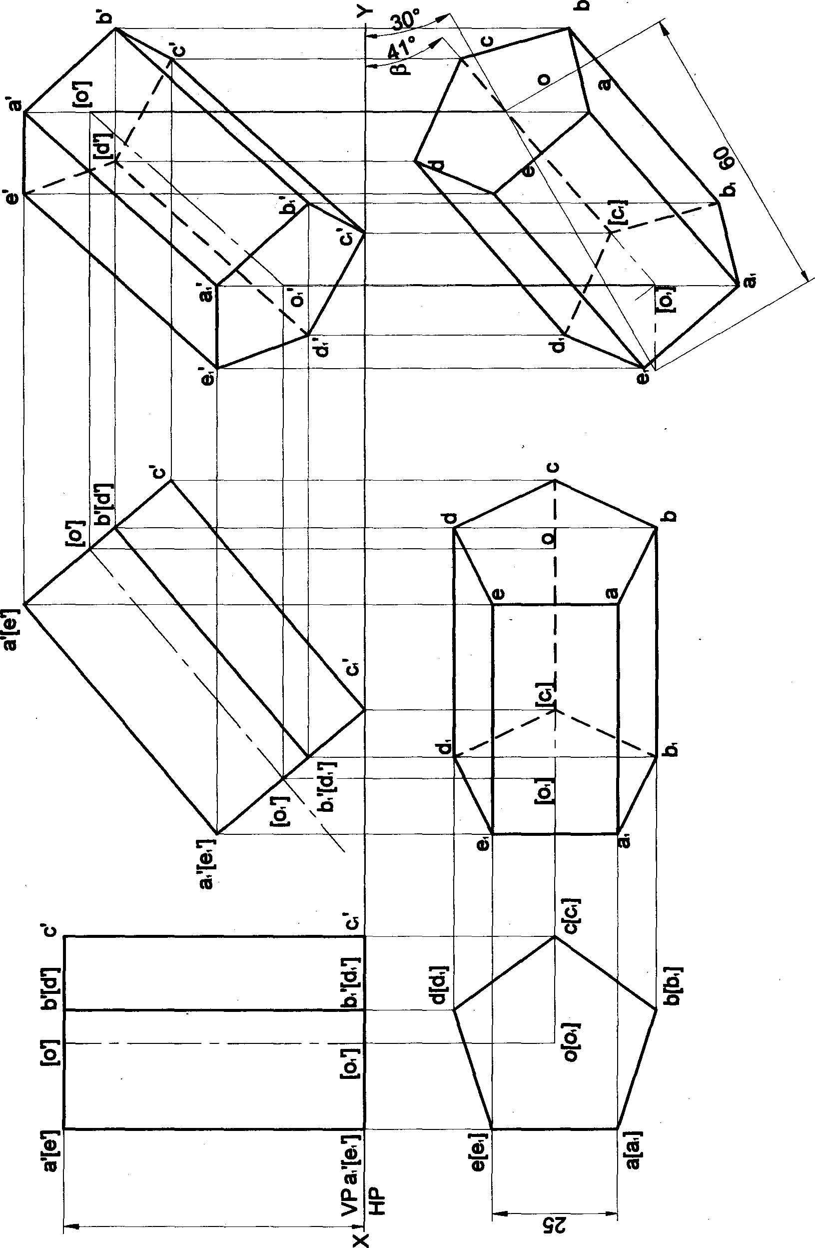

84

Problem 9 A hexagonal prism 25 mm sides of base and 50 mm axis length rests on HP on one of its edges. Draw the projections of the prism when the axis is inclined to HP at 45° and appears to be inclined to VP 40°.

###### Solution

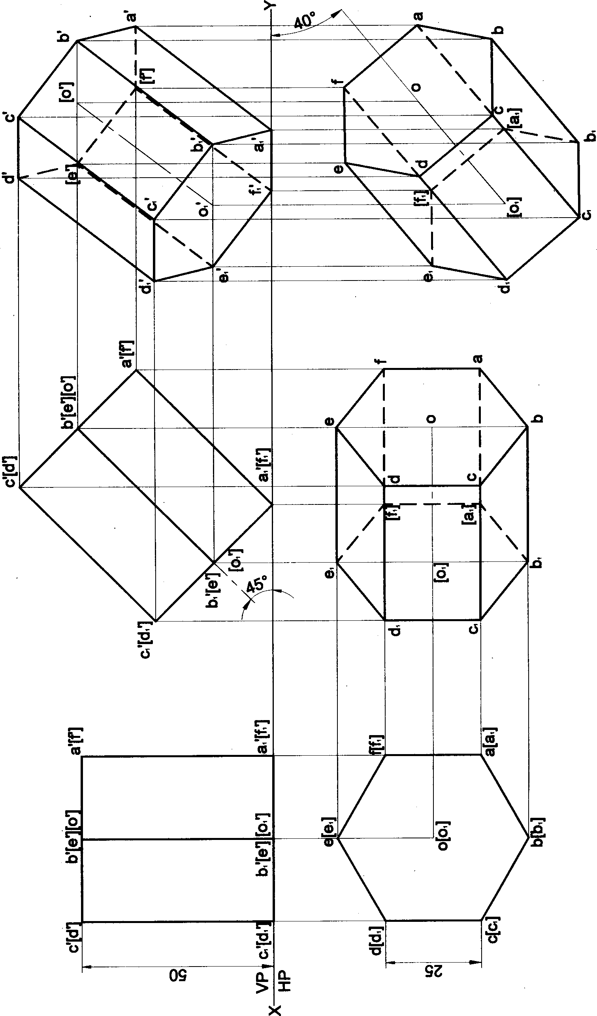

85

Problem 10 A hexagonal prism 25 mm sides of base and 50 mm axis length rests on HP on one of its edges of the base. Draw the projections of the prism when the axis is inclined to HP at 45a and VP at 3fP.

Solution

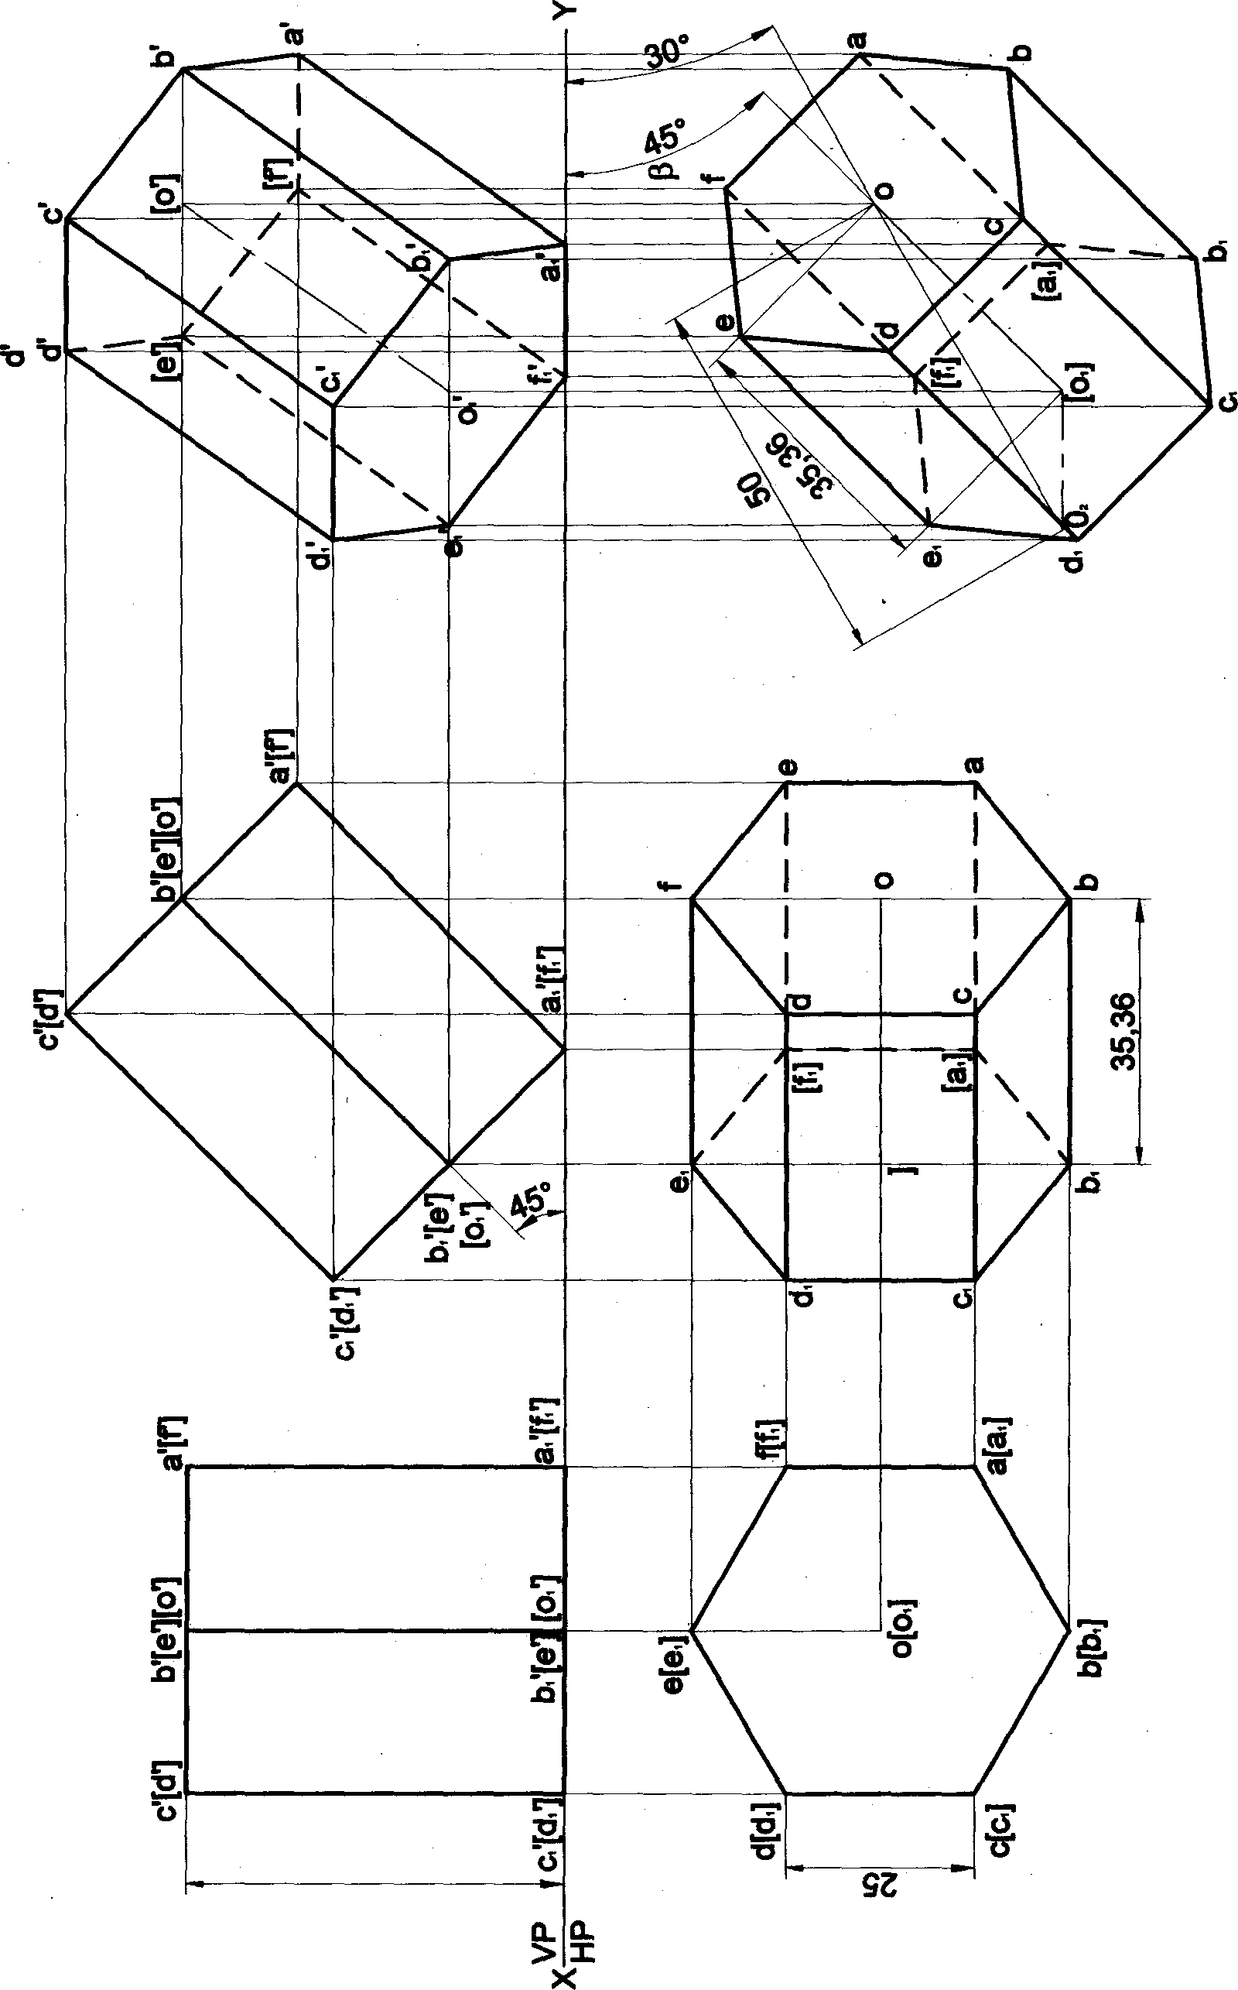

###### 86

Problem 11 A hexagonal prism 25 mm sides of base and 50 mm axis length rests on HP on one of its comers of the base such that the two base edges containing the corner on which it rests make equal inclinations with HP. Draw the projections of the prism when the axis of the prism is inclined to HP at 40a and appears to be inclined to VP at 45a. Solution

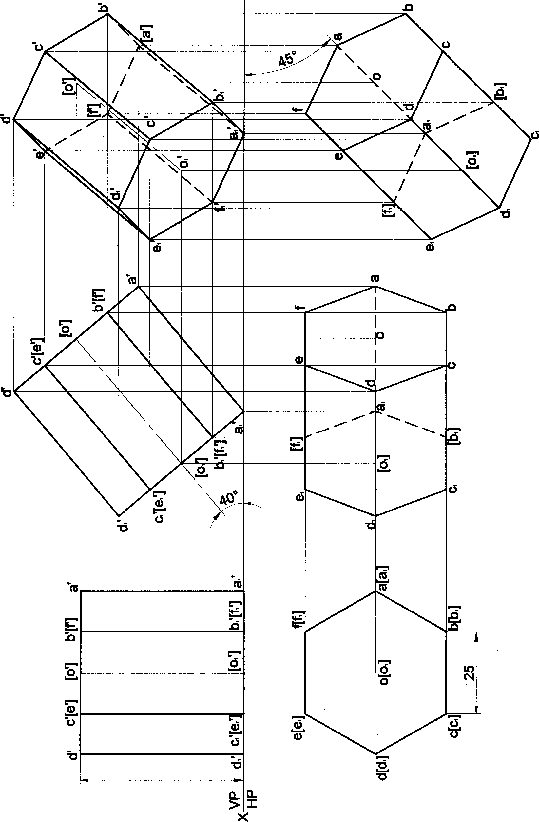

87

Problem 12 A hexagonal prism 25 mm sides of base and 50 mm axis length rests on HP on one of its comers of the base such that the two base edges containing the comer on which it rests make equal inclinations with HP. Draw the projections of the prism when the axis of the prism is inclined to HP at P and to VP at 3fP.

## Solution

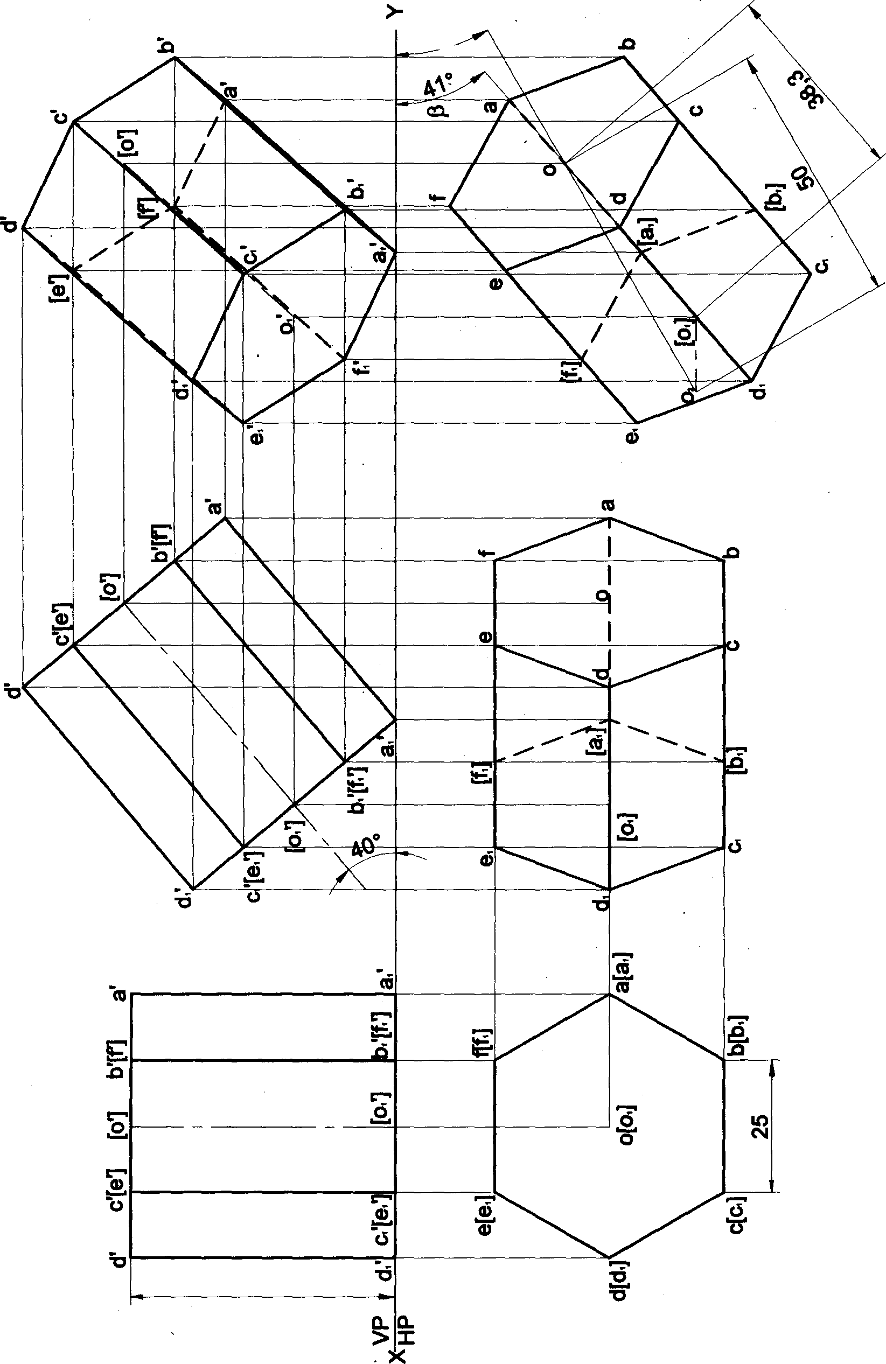

#### 88

68

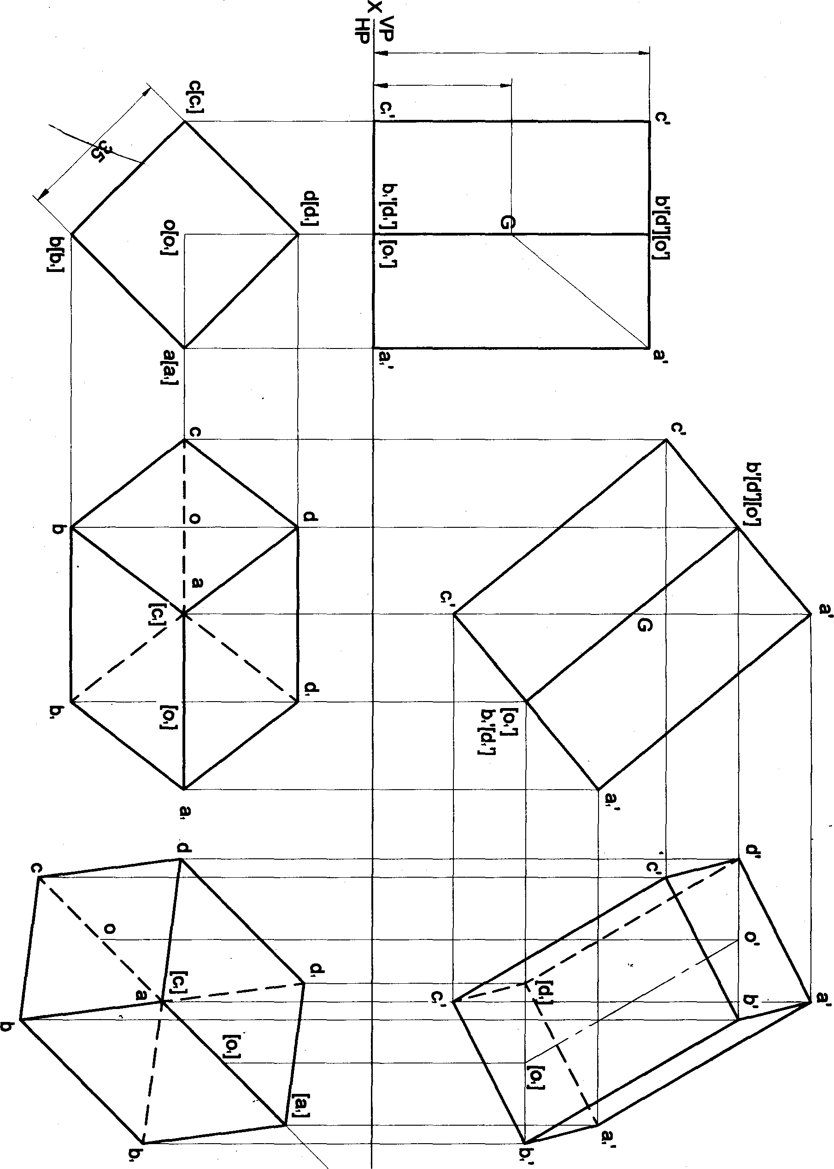

uo jțn| • s

“ gp tø ,gj\ ot pøu!icU! W & sJseddø *! etjț uequ tuspd €łtg }O SU !W țo‹d egg ve‹łg eseq

»! jo ‹eeœ s iuo‹j A¡ee‹ț pepuedsns •! i jóue¡ s! • = gg pus assq țo sep!• > çg uJspd e‹snbs'y’ g ç u zeiq o «d

Problem 14 Apentagonal prism 25 mm sides of base and 50 mm axis length is suspended freely from acomer of its base. Draw the projections of the prism when the axis appeals to be inclined to VP at45^.

## Solution

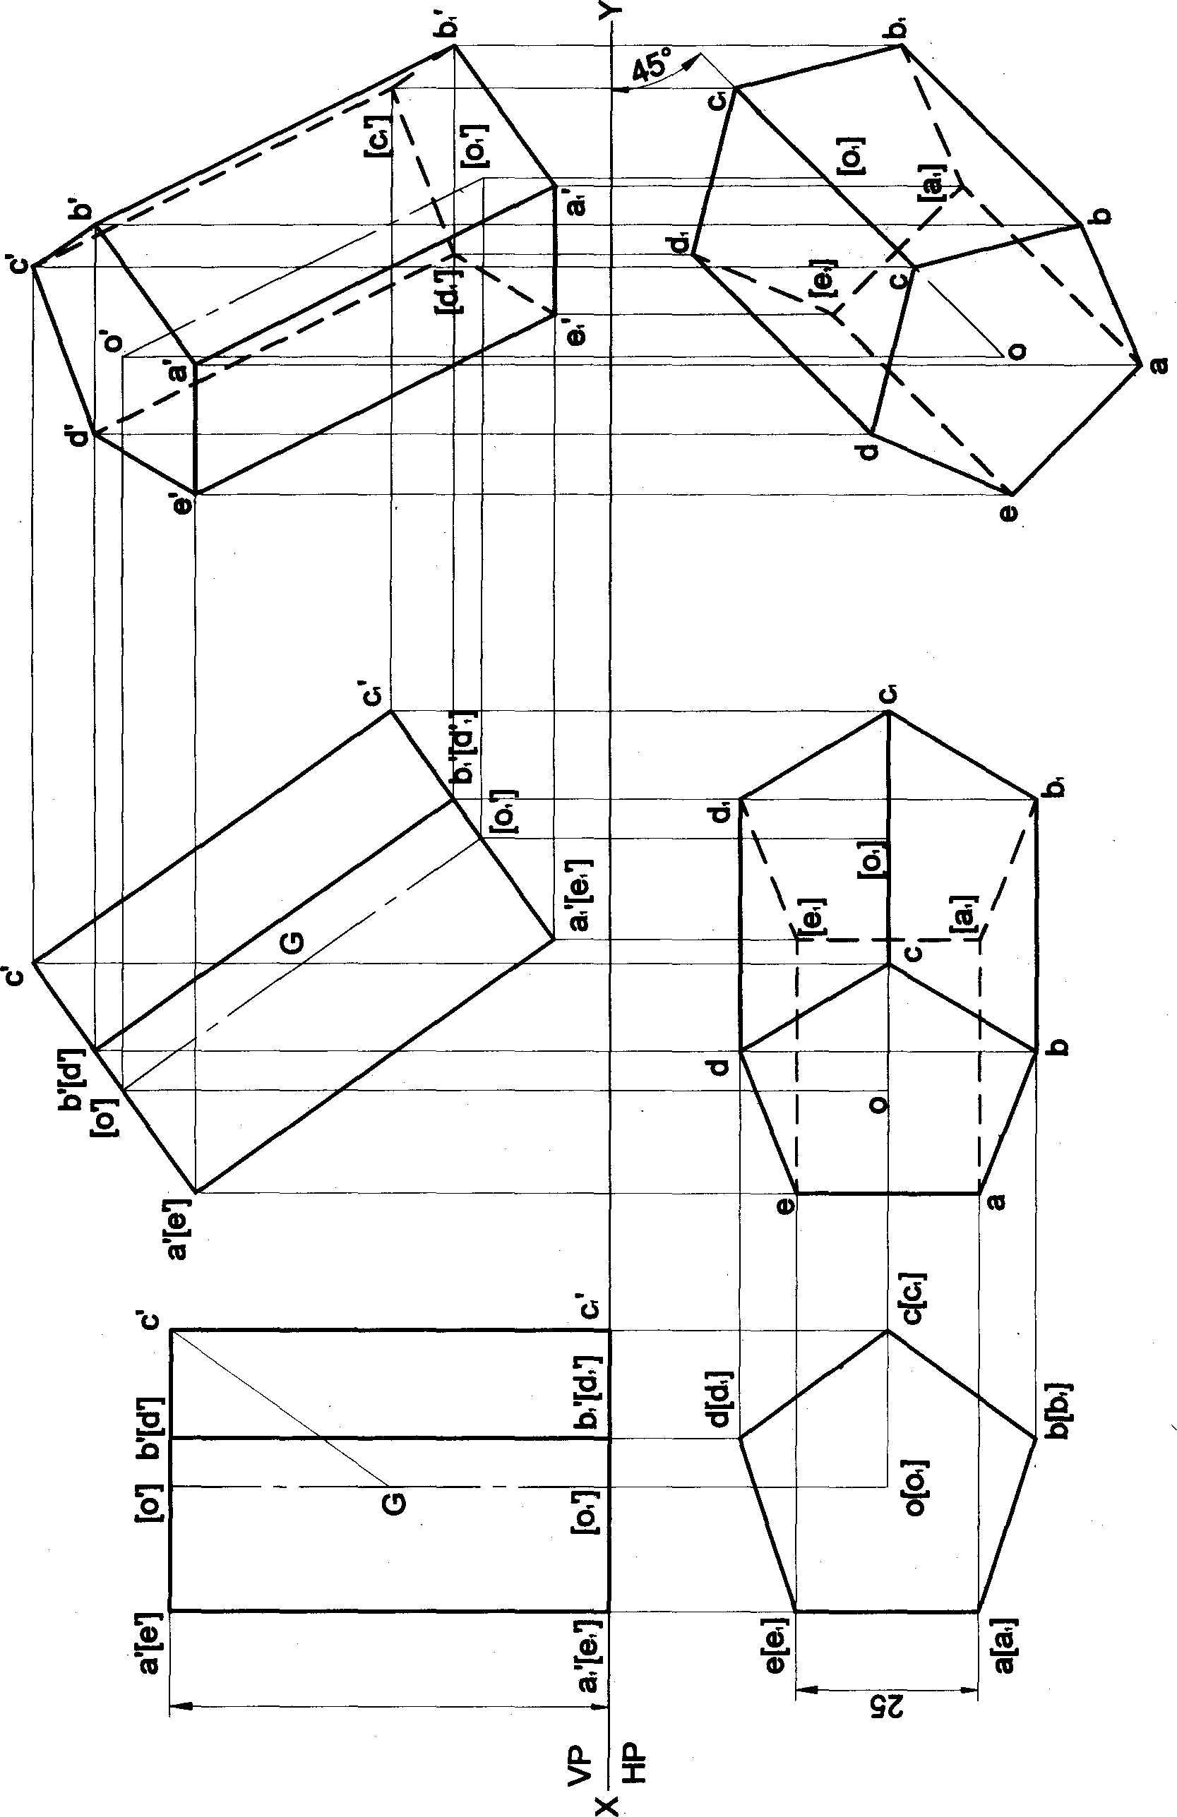

#### 9O

Problem 16A hexagonal prism 25 mm sides of base and 50 mm axis length is suspended freely froma baas. Draw the protections of the prism when the axis appears to be inclined to VP at 45*.

# Solution

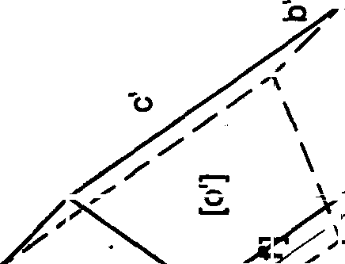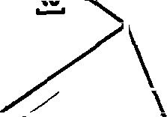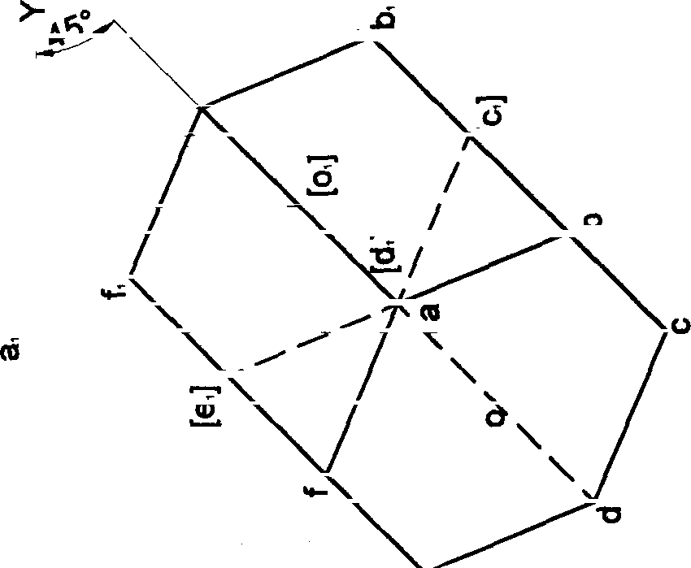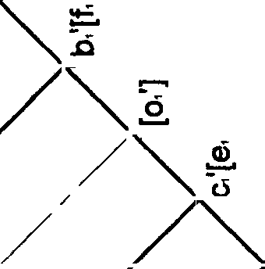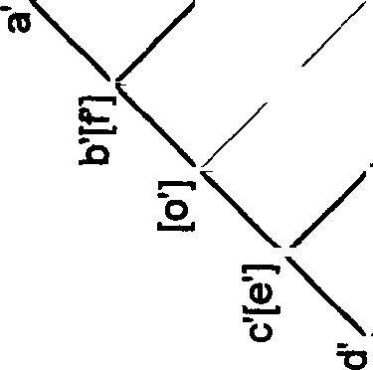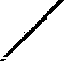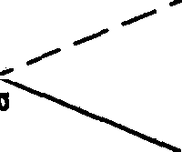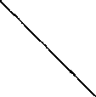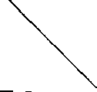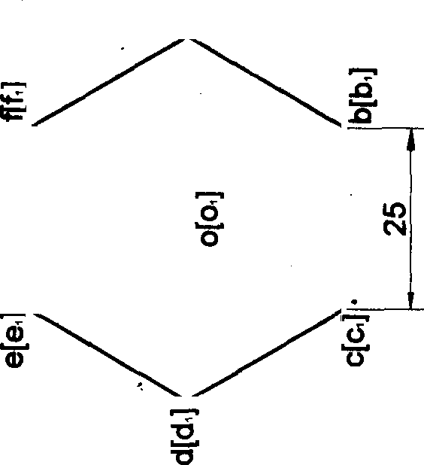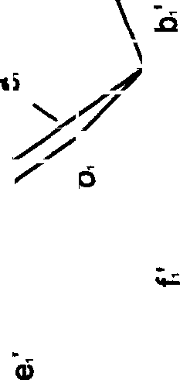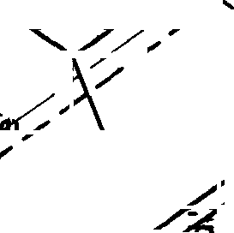

a

t

ì

°

05

[ )’

°

°

dH

u‹

.‘° [.‘i›.‘

[,‘ol

[,‘a],* .‘

,e

[y ,q

[,o]

Ęe ,c

,p

16A square pyraiyiid 35 mm sides of base and 05 mm axis length rests on HP on one of its edges of the

base which is inclined to VP at 30°. Draw the projections of the pyramid when the axis is inoliflBd tO HP at 4S°.

### Solution

92

Problem 17 A square pyramid 35 mm sides of base and 60 mm azis length rests on HP on one of its comers of the base such that the two base edges containing the comer on which 'it rests make squat inctinations with HP. Draw the projections of the pyramid when the axis of the pyramid is inclined to HP at 40° and appears to be inclined to VP at 45^.

### Solution >-

93



ww sides oibase «•a ea «•• axi» le»eth reats onHP on on• of*s œz›ææ o! the

pyiamkl when the axle of the p¥j@IylÏÖ l8 lnCItf›eÖ tO HP at 4¢P ariÖ to VP at 3Œ.

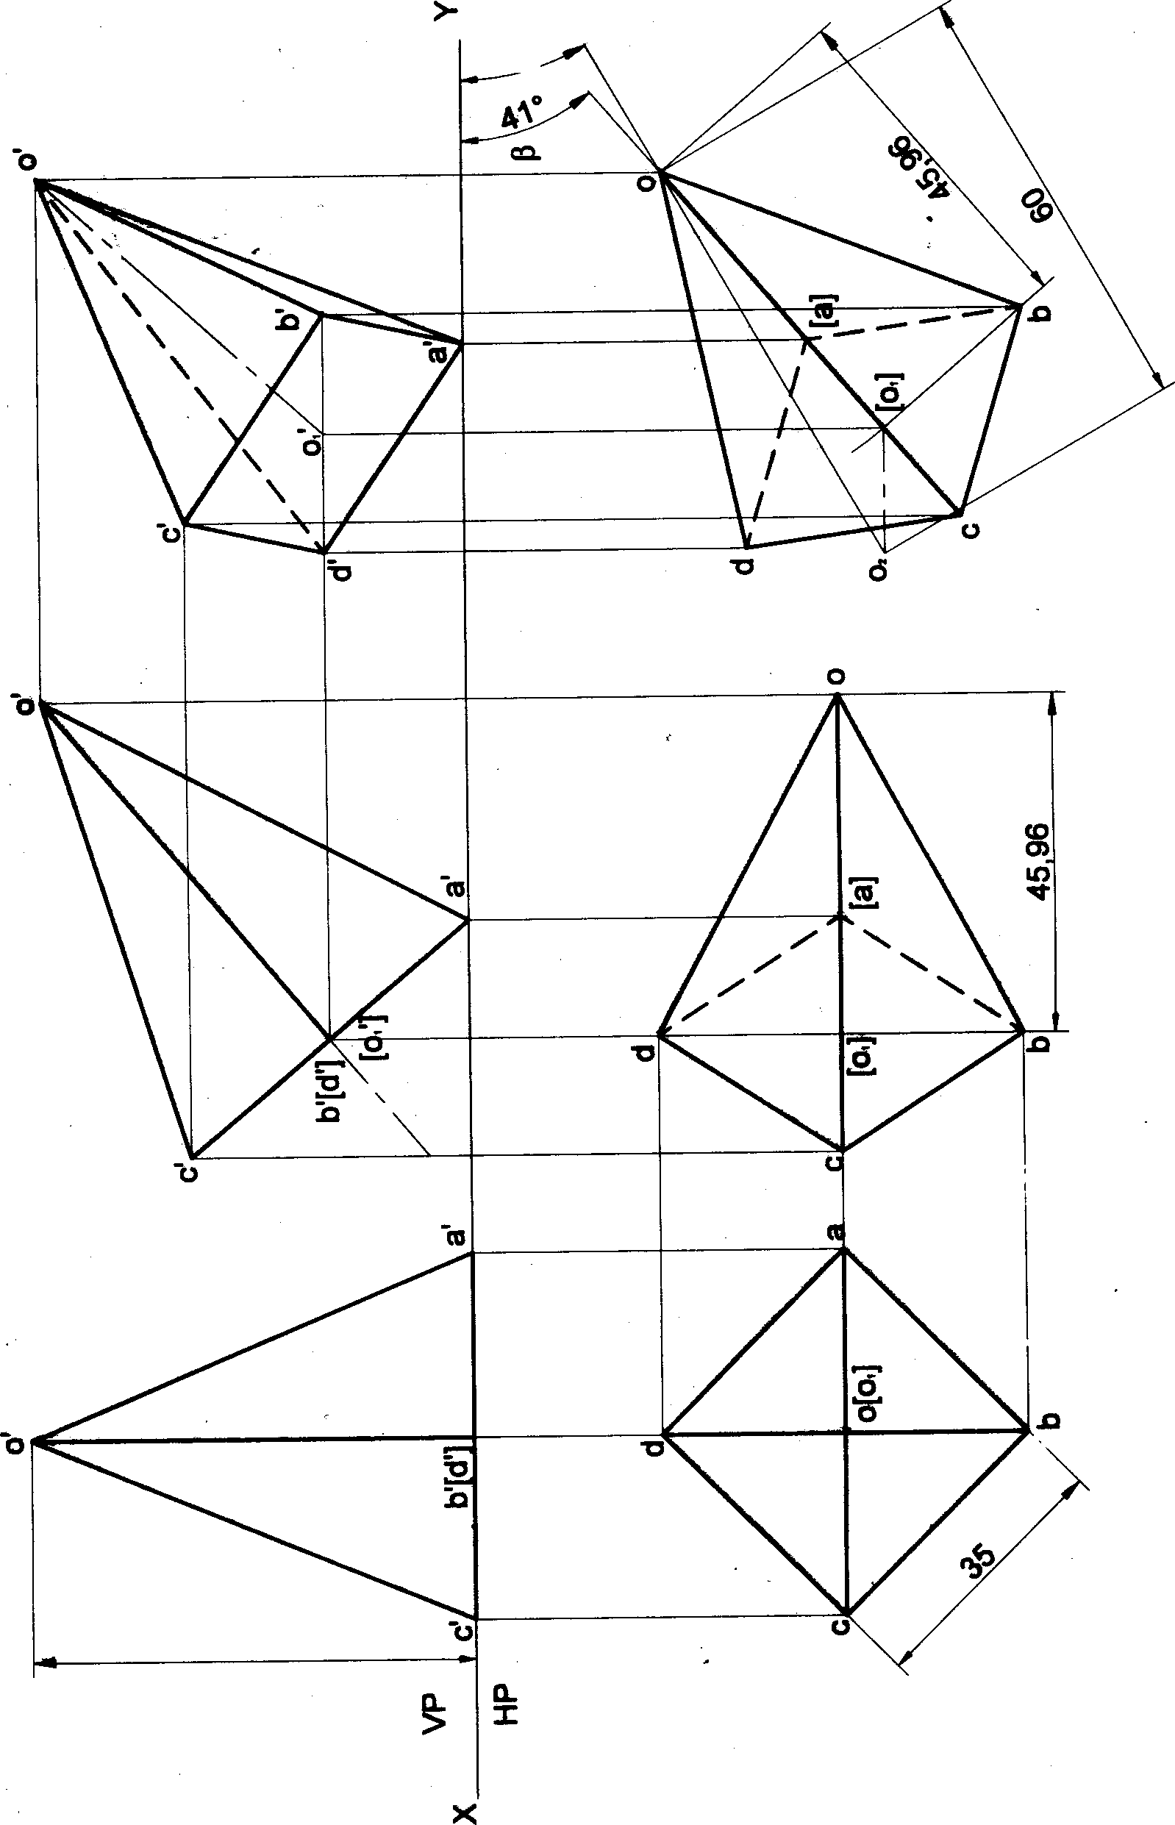

e‹

Problem 19 A square pyramid M mm sides of base and 60 mm axis length rests on HP on one of its edqaa of the base. Draw the projections of the pyramid when the axis is inclined to HP at 4@ and VP at 30*.

Solution

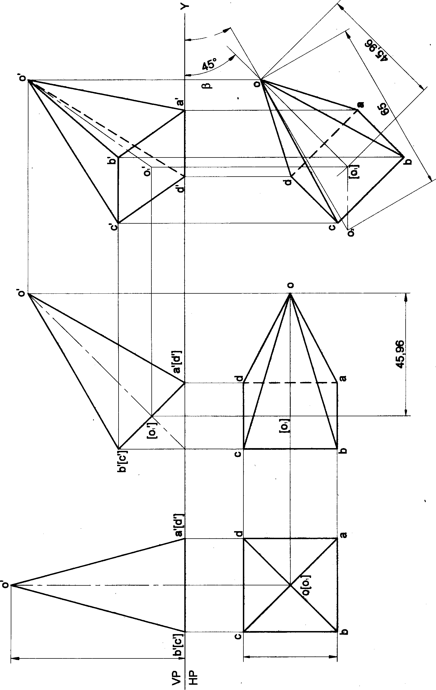

###### SE

95

Problem 20 A pentagonal pyramid 25 mm sides of base and 60 mm axis length rests on HP on one of its edges of the base which is inclined to VP at 30•. Draw the projections of the pyramid when the axis is inclined to HP at 40°. Solution

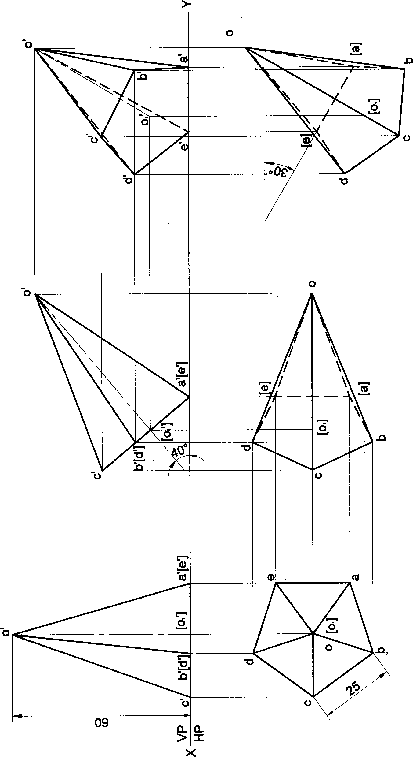

96

Problem 21 A pentagonal pyramid 25 mm sides of base and 50 mm axis length rests on HP on one of its edges of

the base. Draw the projections of the pyramid when the axis is inclined to HP at 45° and VP at 3¢P.

###### Solution

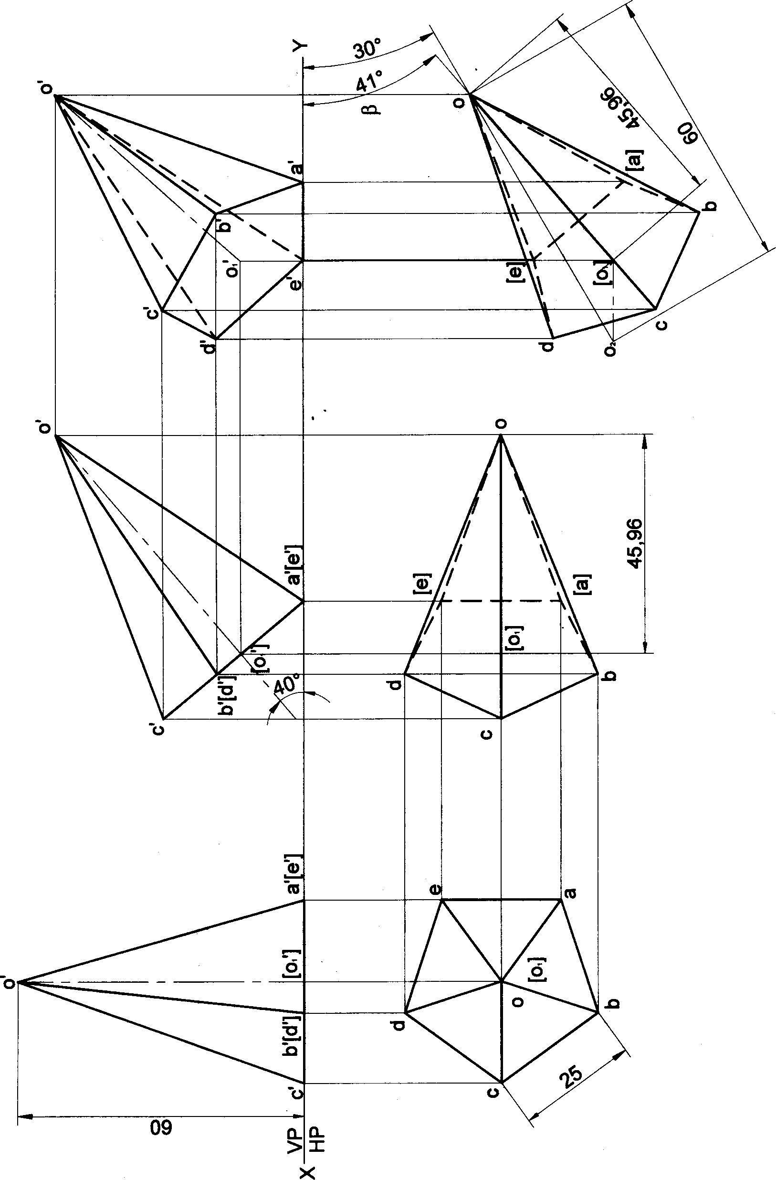

97

Problem 22

the base auch 

## Solution

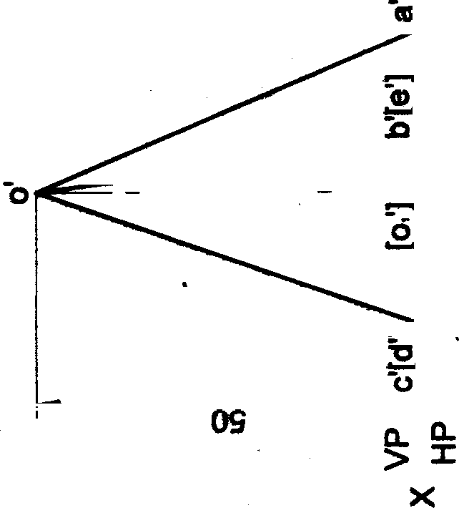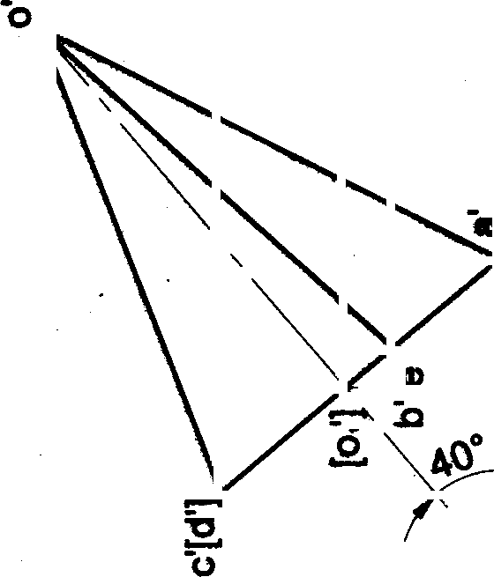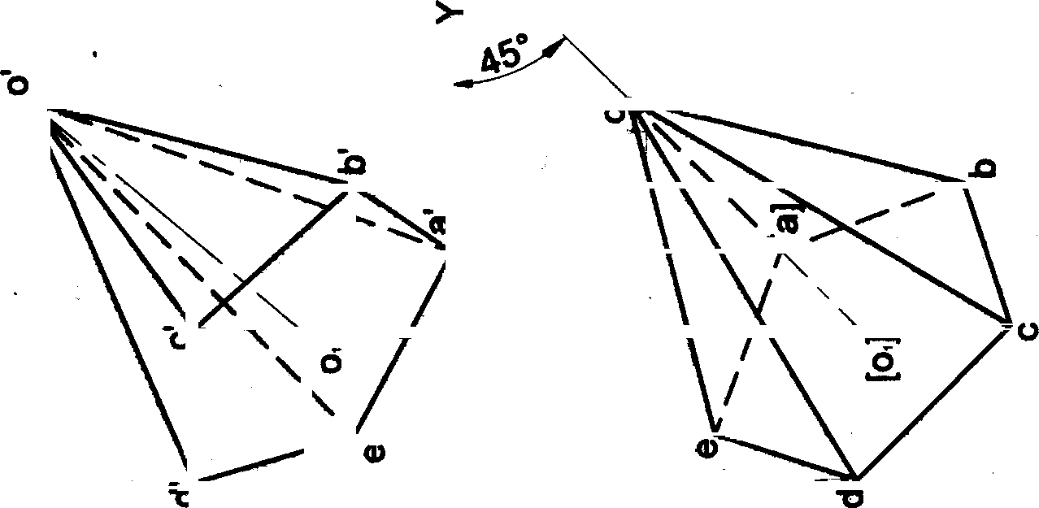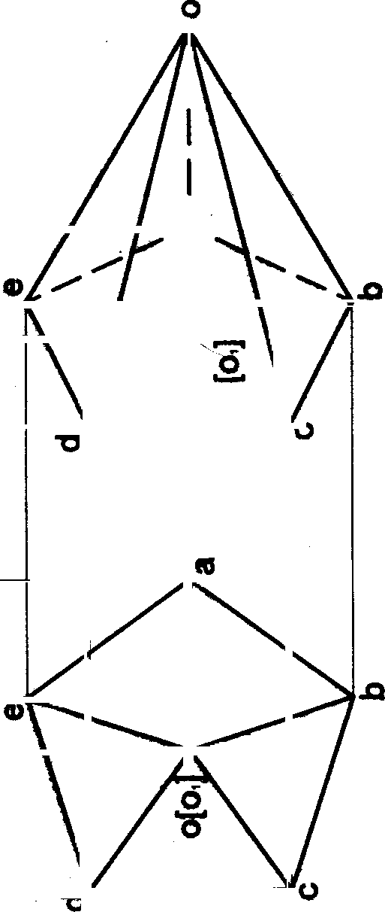

Sõ



66

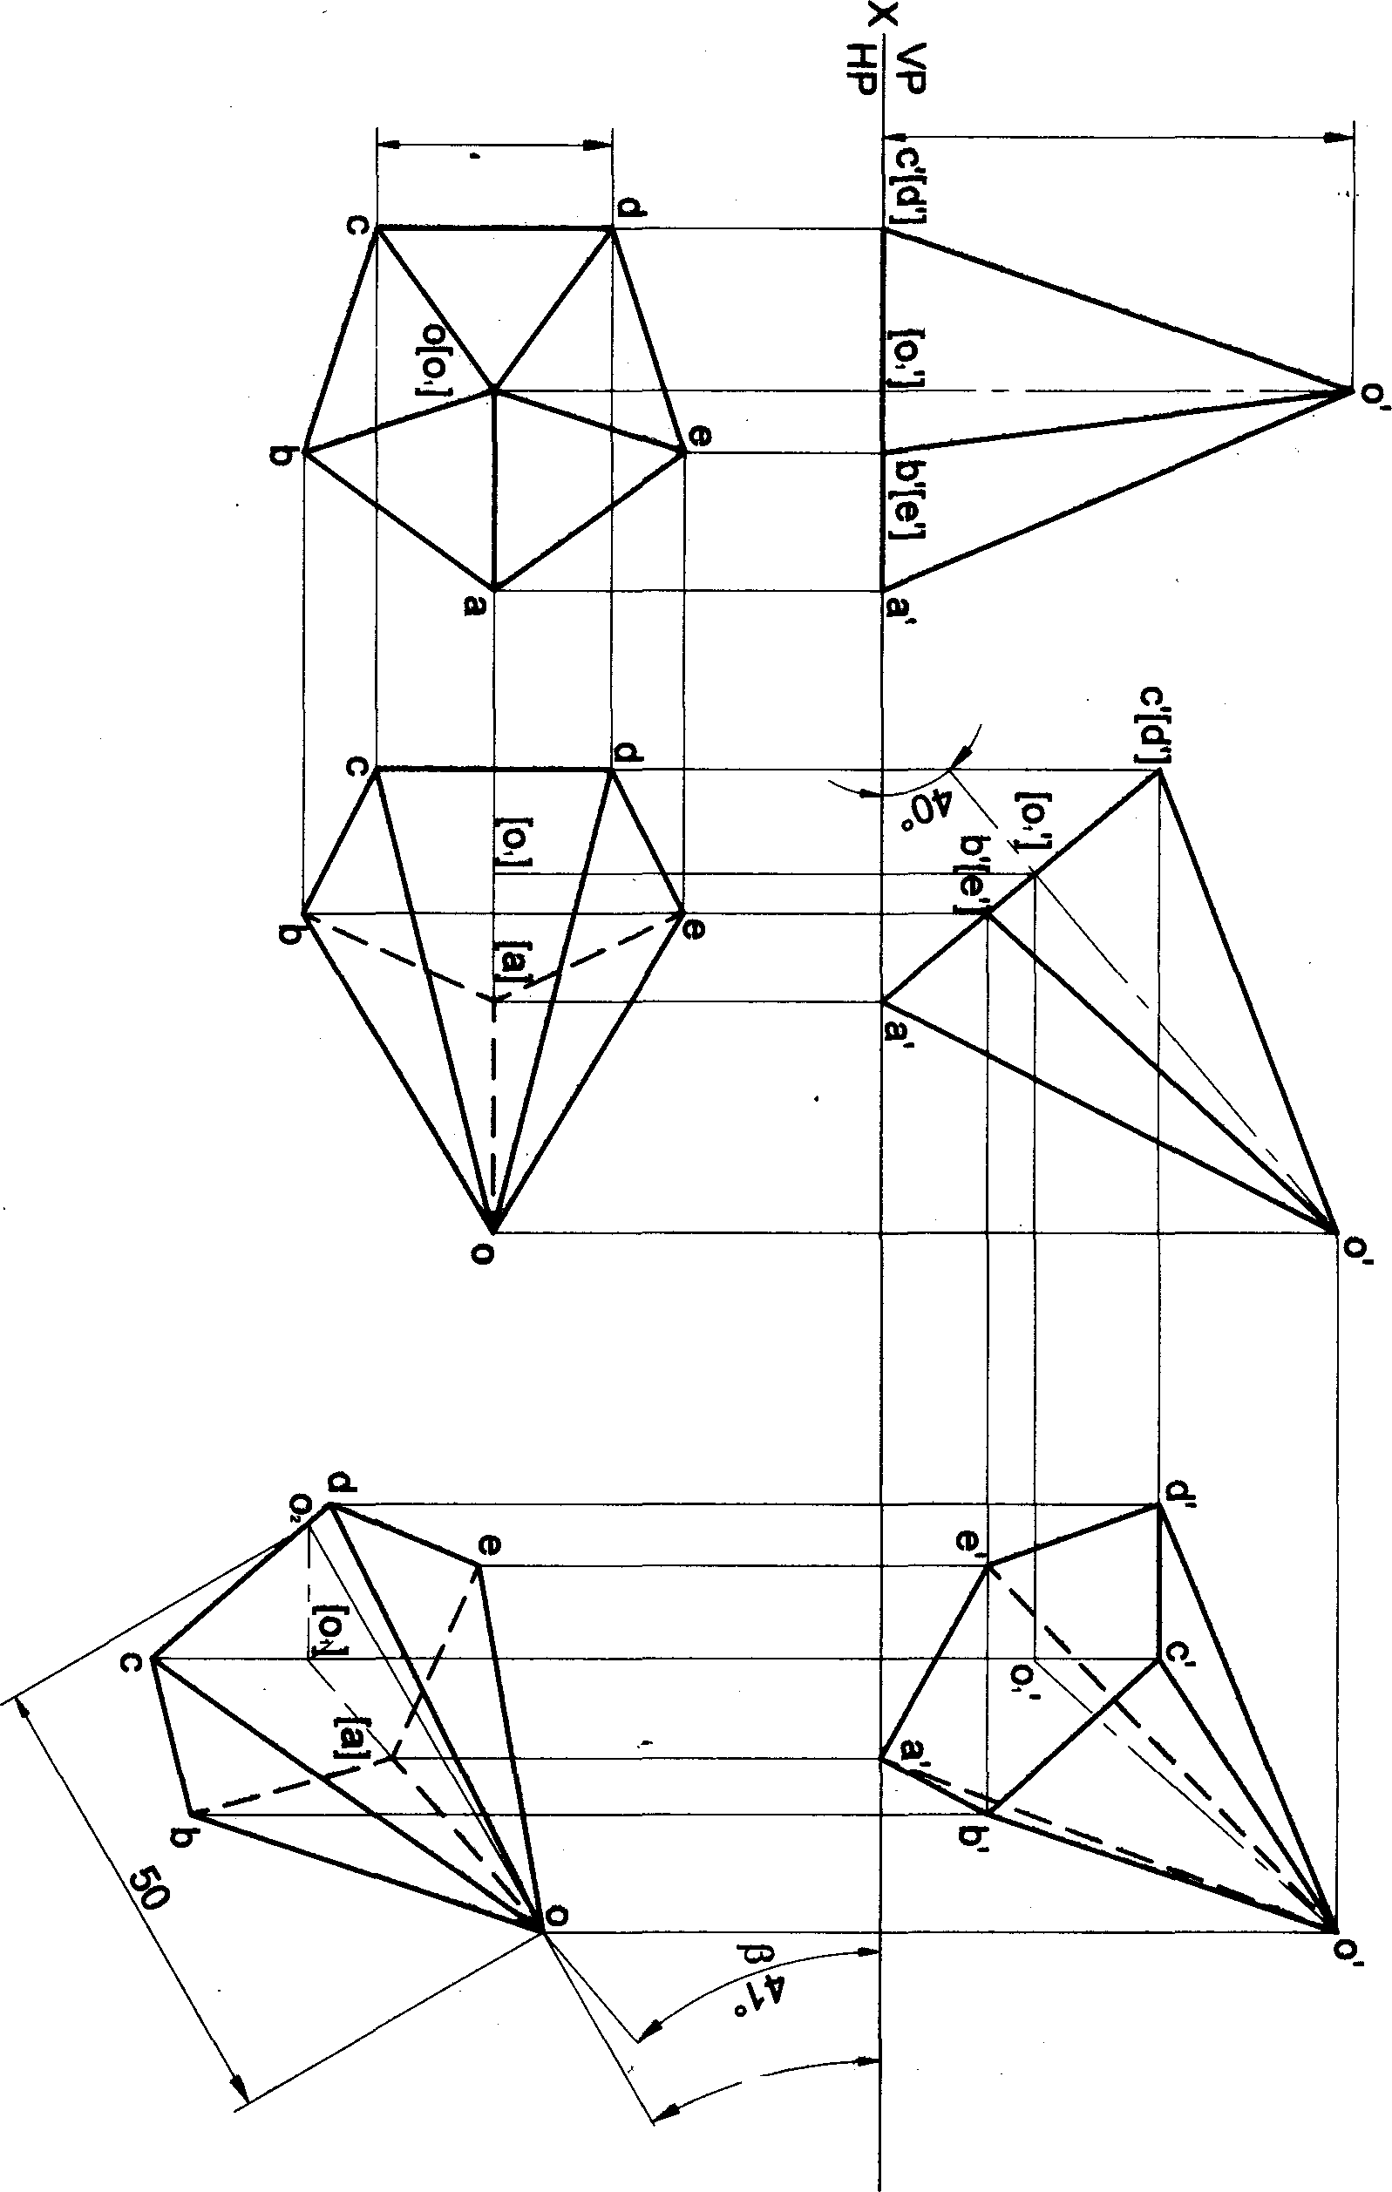25 50

# uopn¡og

' 0g t® dA O} UB gg$' t dH O} !I ! ^! P! *gl I ! 8Qt U6W P! e JZd est jo suopae{o‹d ego

#### ^s‹O ‘dH ta s euos.wIPu! ‹enbe eq steaz y qojt n uo‹euzoc etg 8ui.ujaiuoa se0pe eeeq ou eigtsqi pans esaq ego

##### ja azeuzos sy ja euo uo uo sisai t¡I0uej etxa uxu ggpue esaq jo septs u«u gg piuieizd suo0aluedy’ gg zuejq0Jd

Problem 24 A hexagonal pyramid 25 mm sides of base and 50 mm axis length rests on HP on one of its edges of

the base which is inclined to VP at 3fP. Draw the projections of the pyramid when the axis is inclined to HP at 45a.

Solution

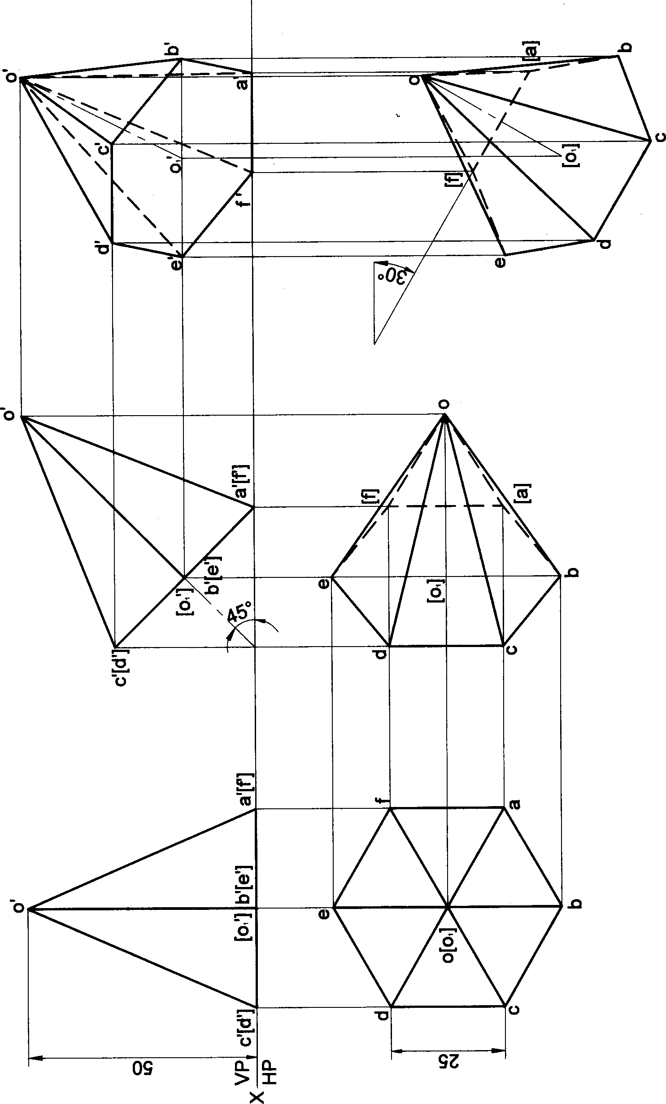

100

Problem 25 A hexagonal pyramid 25 mm sides of base and 50 mm axis length rests on HP on one of its edges of the

base. Draw the projections of the pyramid when the axis is inclined to HP at W and VP at W.

###### Solution

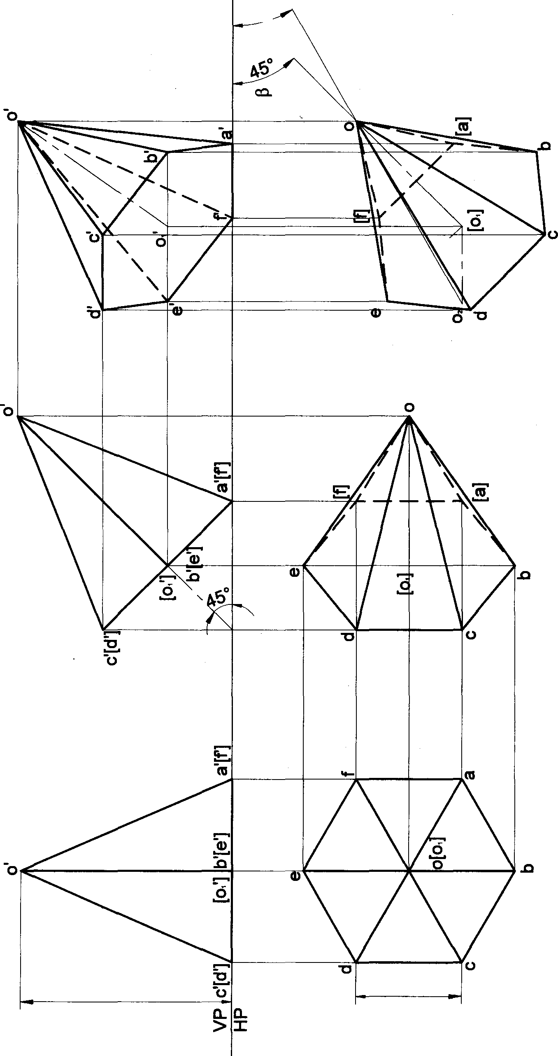

101



the projections of tI'›s pyramid when the axis of tha pyfemid is i»cli•ed to HP at W and appears to be inclined to VP

at45^.

# solution

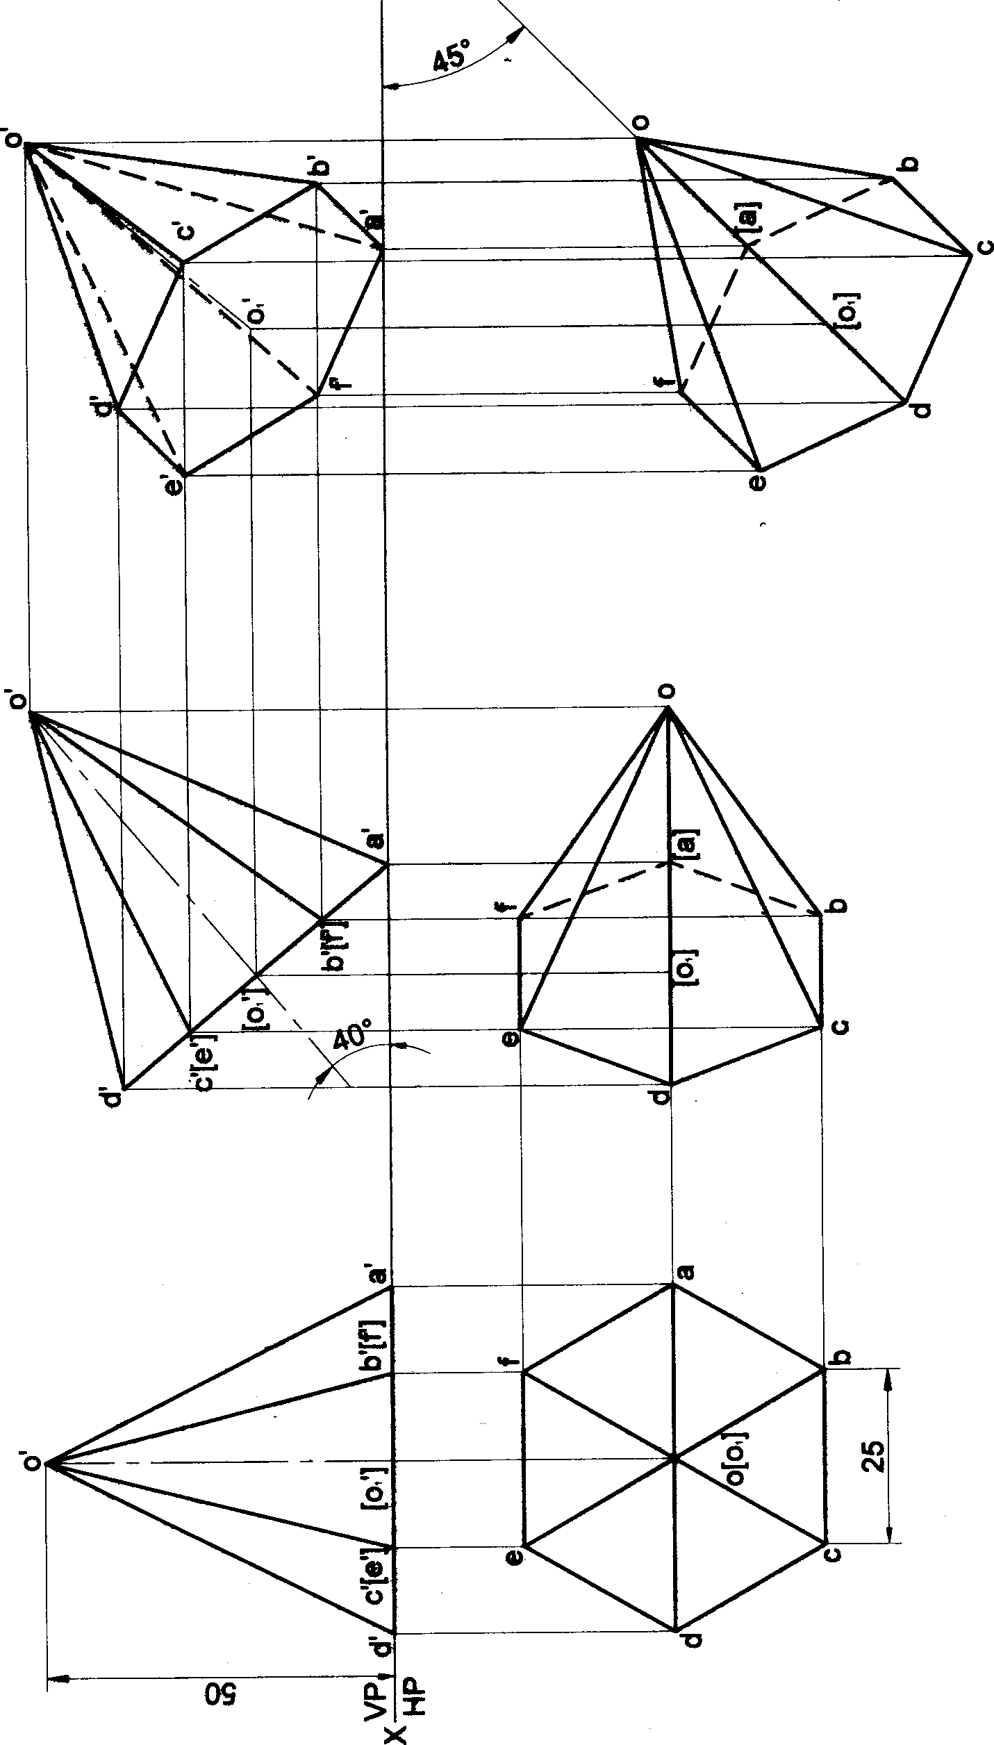

102

Problcat 27 A hexagonal pyramid 25 mm sides of base and 50 mm axle length feels on HP on one of ib comem of the ba6e suCh that the two baae edg08 contañling the Oofrler on which it iastB zfi0lte etjlzsl IzWlnations with HP. Dr8W the projections of the pyramid when the axis of the pyramid Is Inclined to HP at 40* arid to VP at 30•.

#### Solution

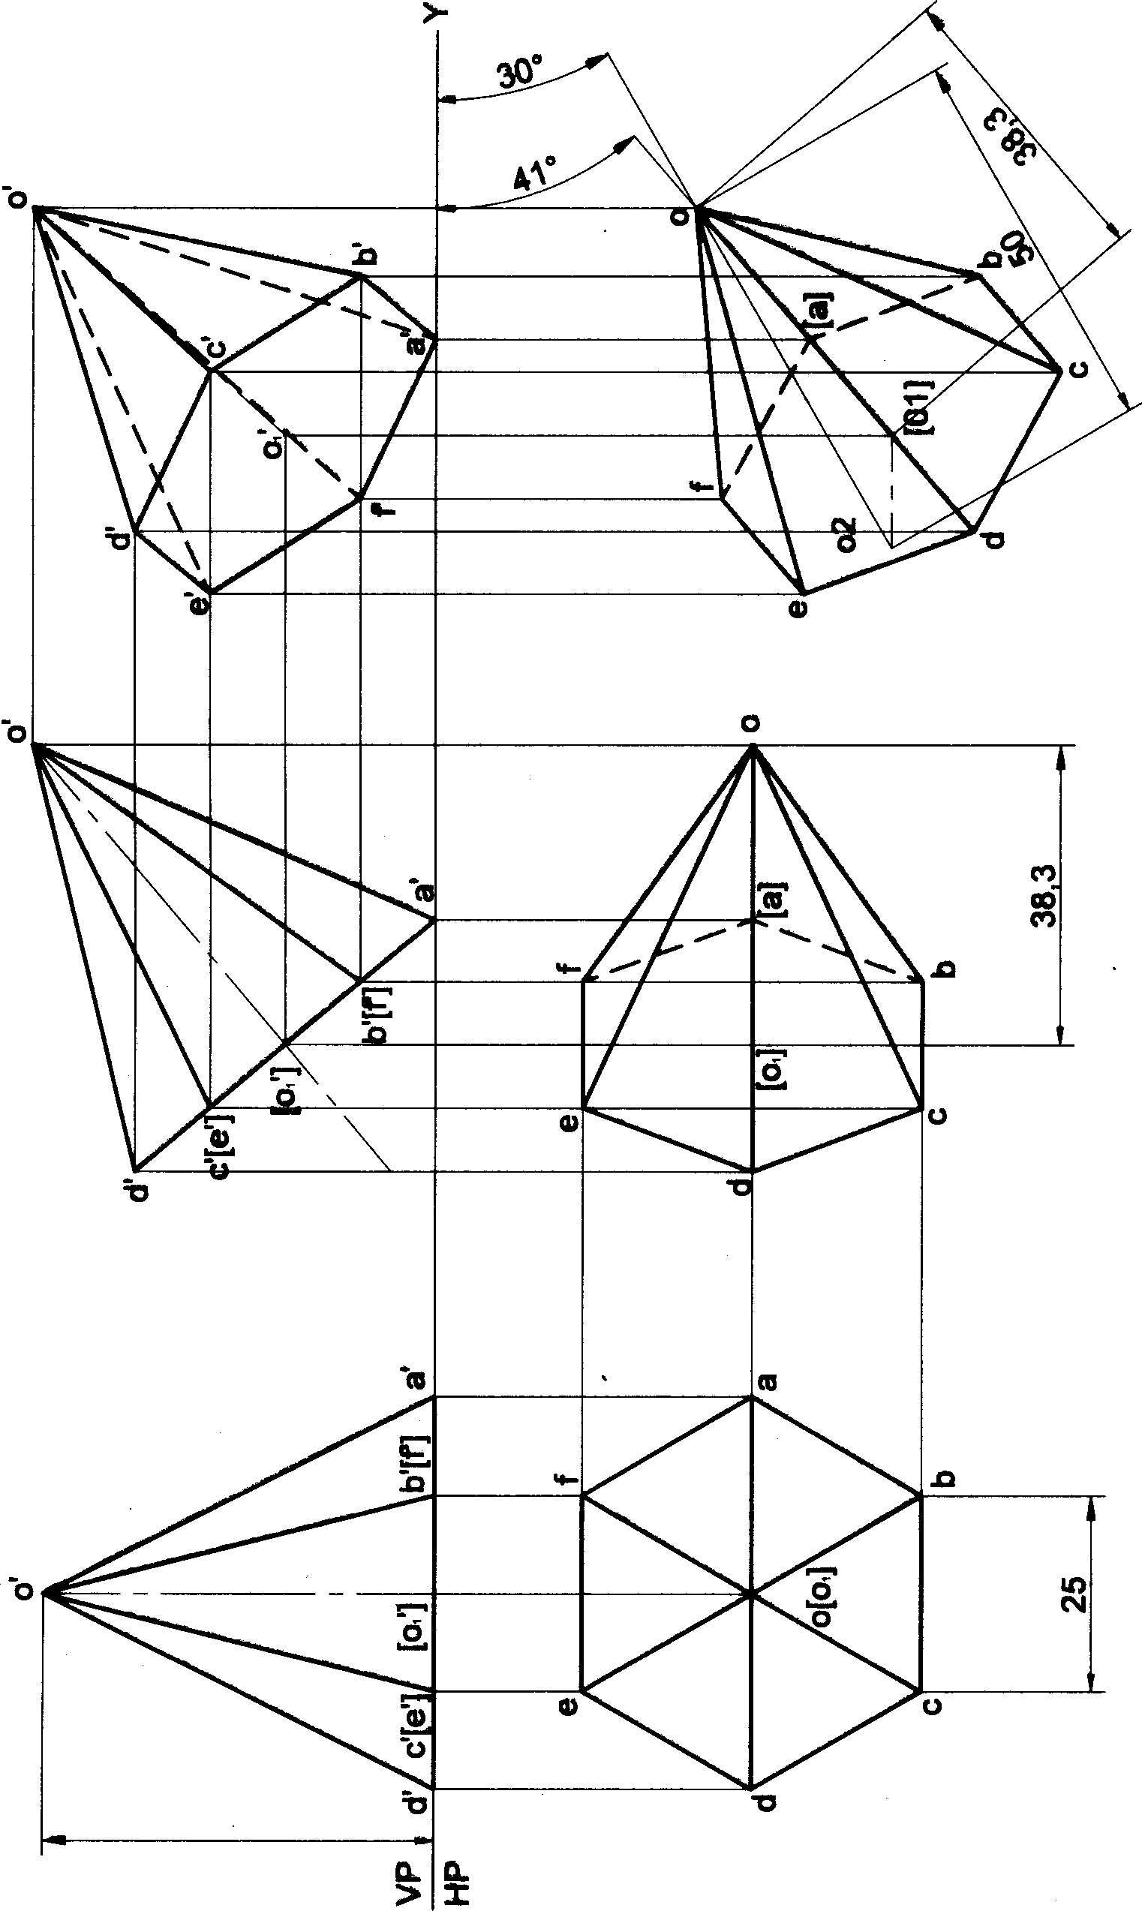

##### 05

103

Problem 28 A square pyramid 35 *mm* sides of baee and 60 mm axis length is suspended freely from a comer of its Draw the projections of the pyramid when the axis appears to be inclined to VP at 45°.

##### Solution

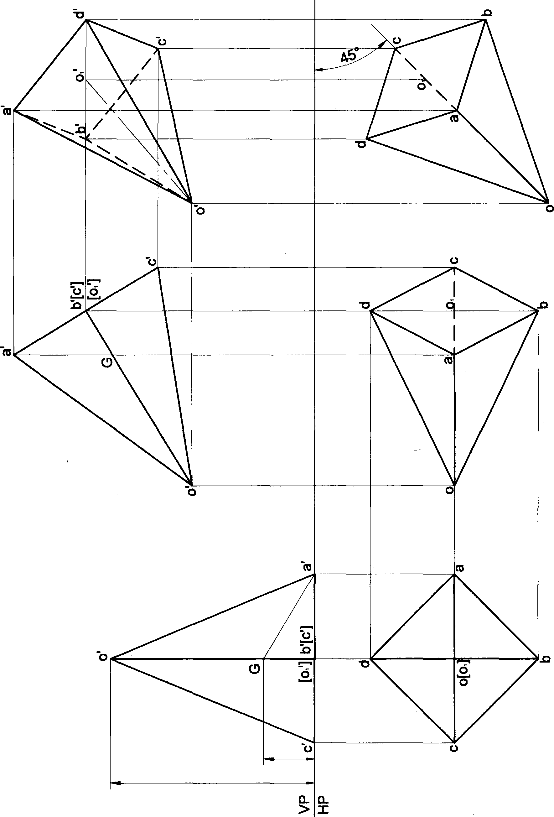

104



Problem 28 A pentagonal pyramid 25 mm sides of base and 50 *mm* axis length is suspended freely from a oomer o

its base. Draw the projections of the pyramid when the axis appears to be inclined to VP at 45°.

##### Solution

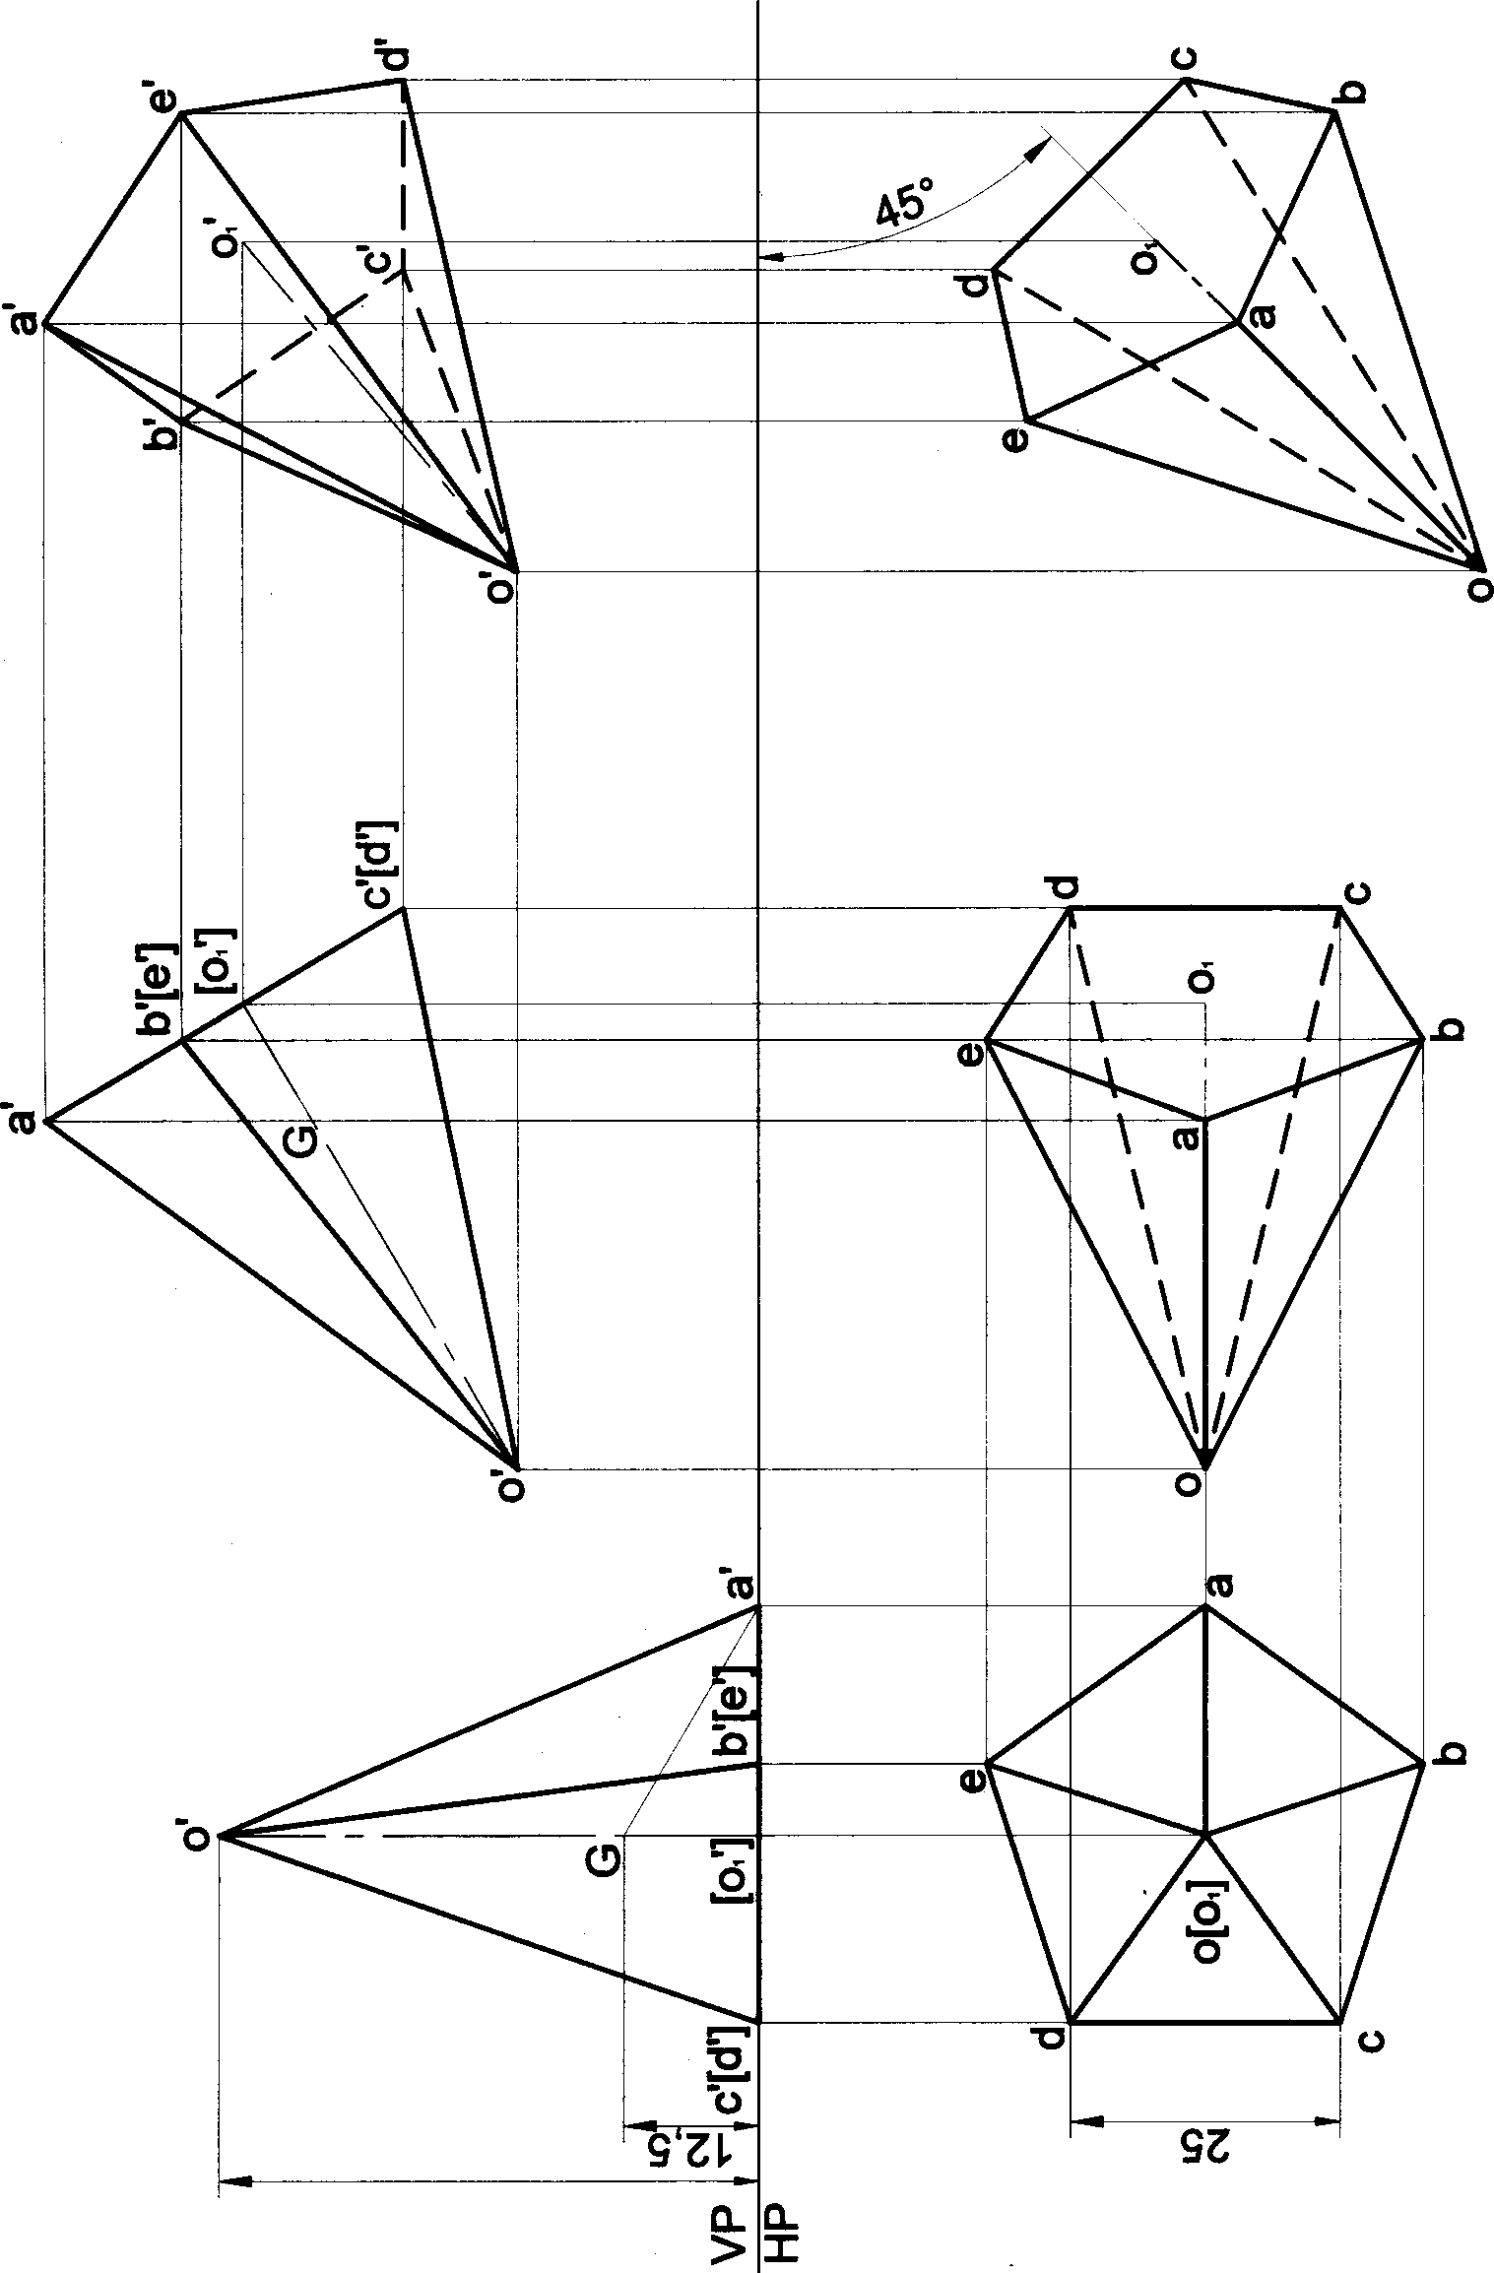

105

Problem 30 A hexagonal pyramid 25 mm sides of ba9e and 50 mm axis length is suspended freely fromacomer of its base. Draw the projections of the pyramid when the axis appears to be inclined to VP at 45°.

# Solution

##### 05

###### 106

sides of base and 60 mm axis length rests on HP on one of its slant edges the axis appears to be inclined to VP at 45°.

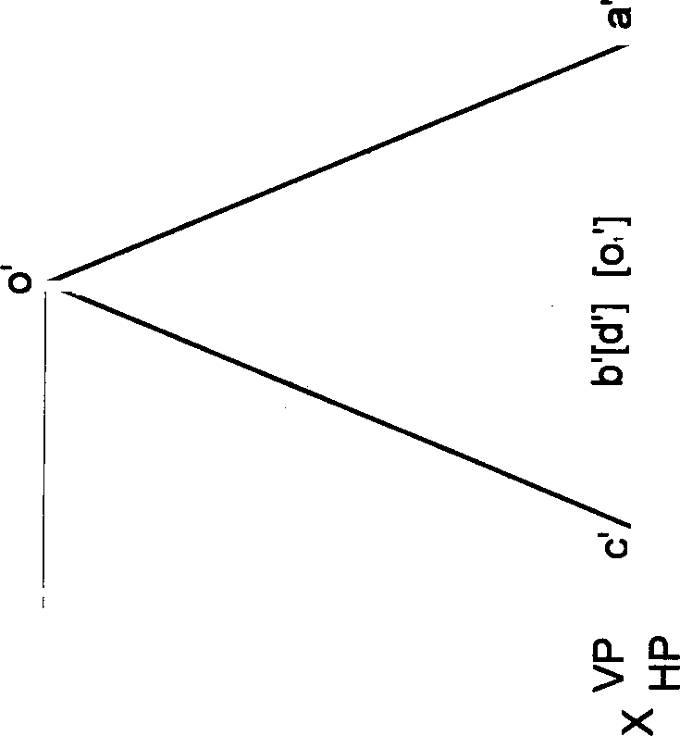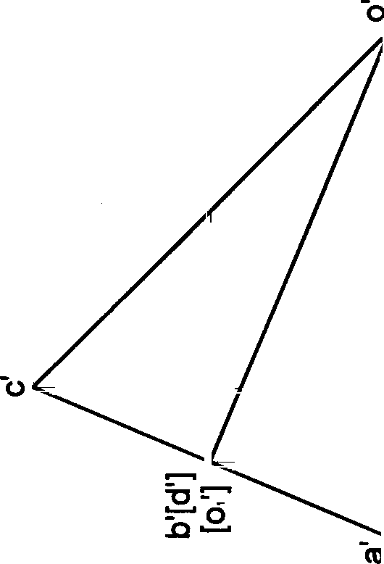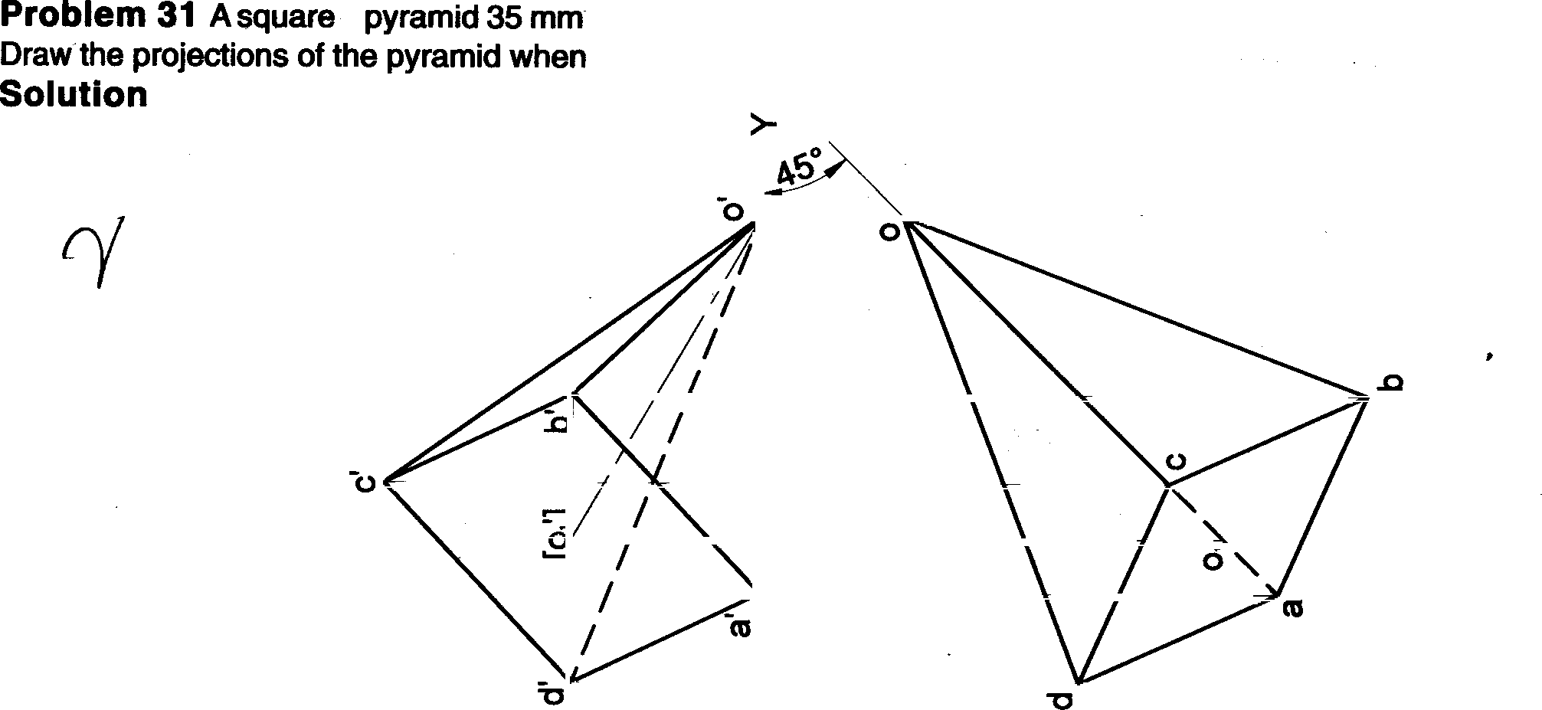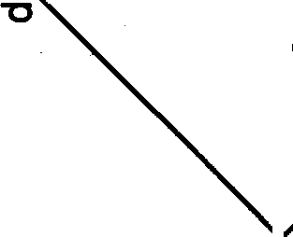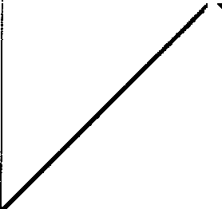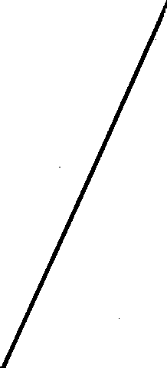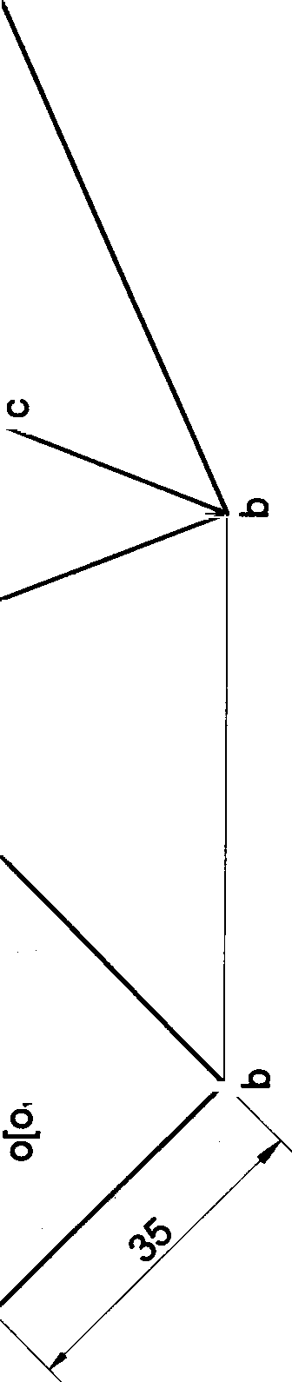

I

Ol

107

Problem 32 A square

pyramid 35 mm sides of base and 60 mm axis length rests on HP on one of its slant edges.

Draw the projections Of the pyramid when the axis is inclined to VP at 45

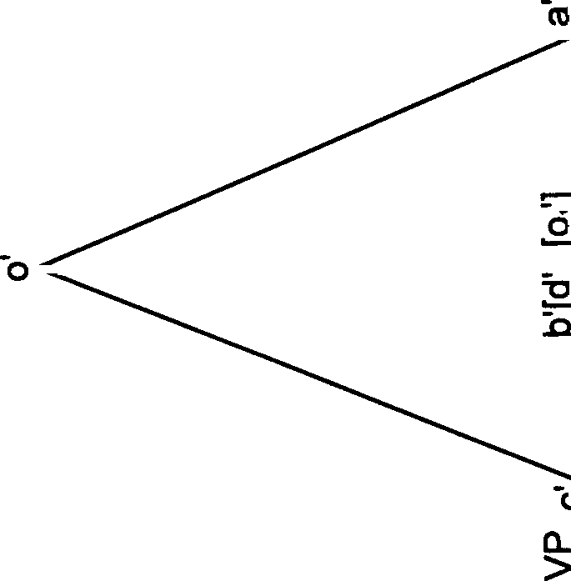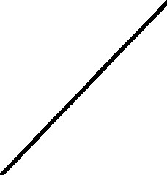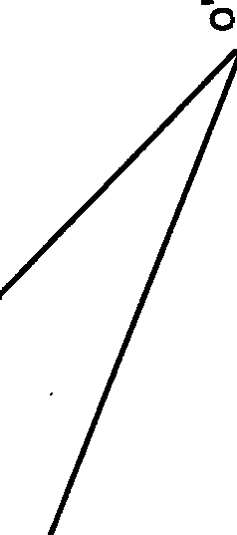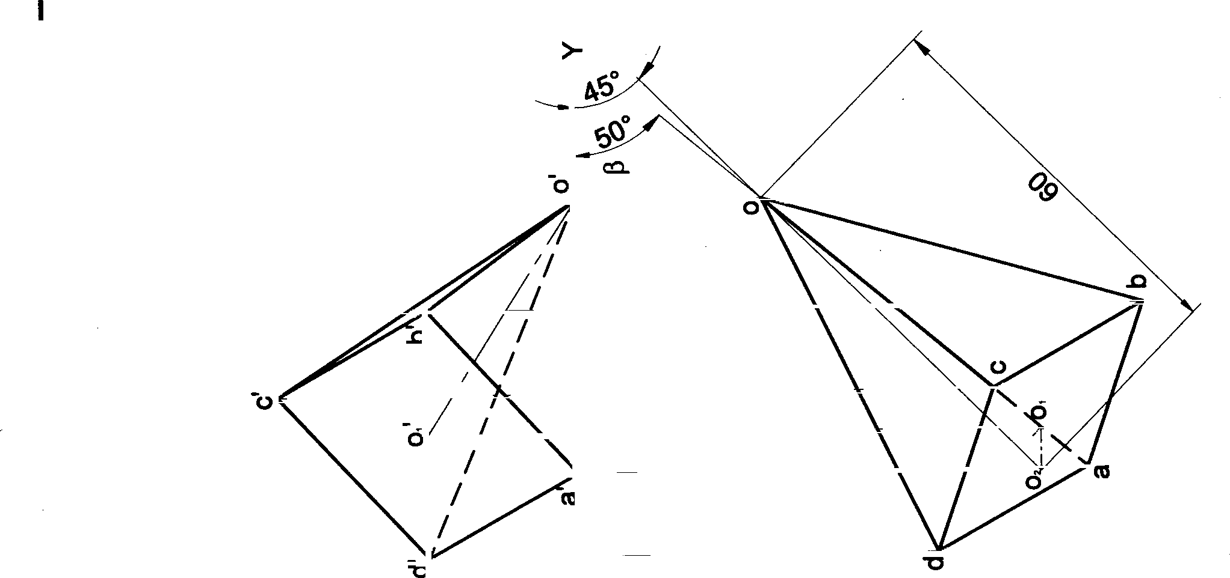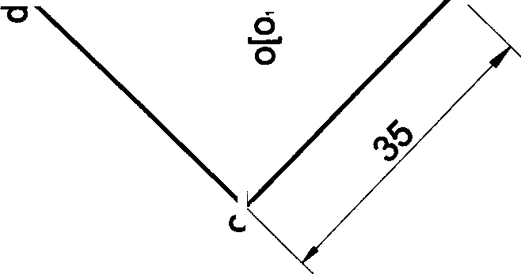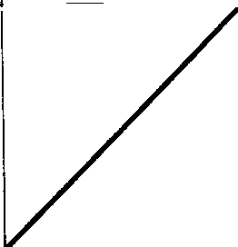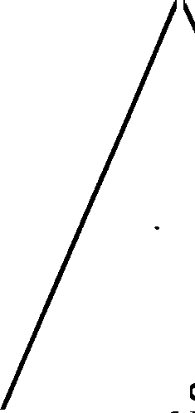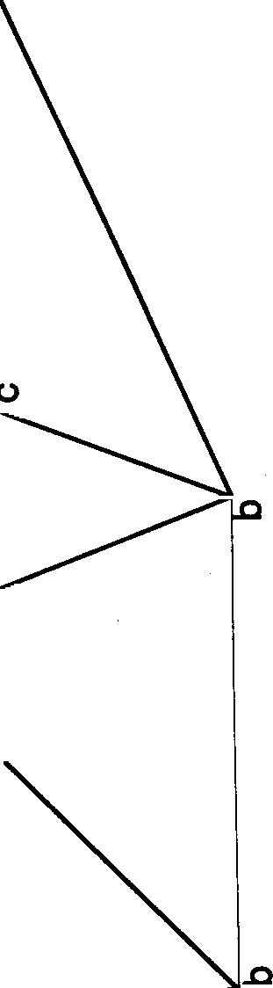

#### So ution

108

Problem 33 A square pyramid M mm sides of base and 60 mm axis length rests on HP on one of its slant triangular

faces. Draw the projections of the pyramid when the axis appears to be inclined to VP at 45^.

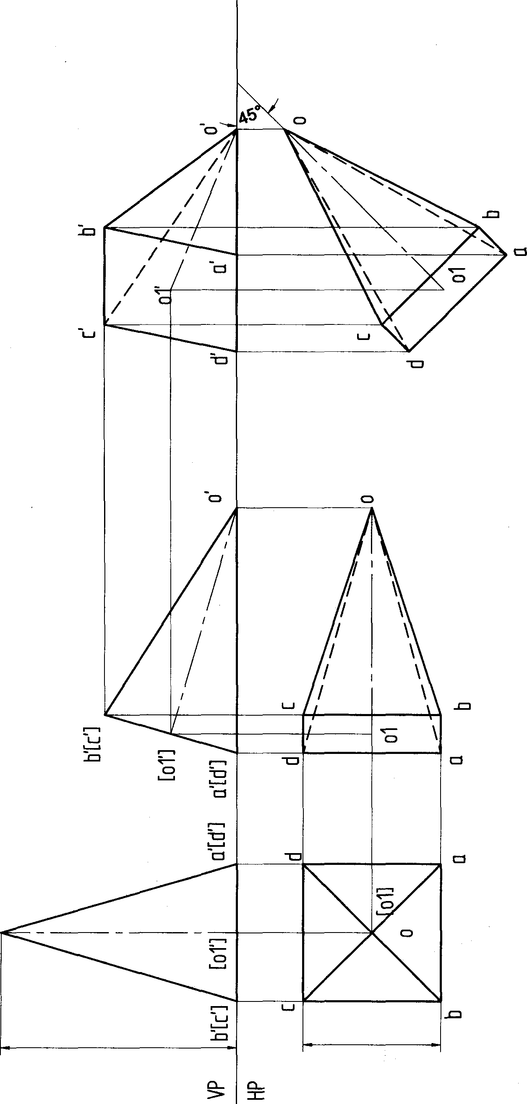Solution

0'

109

Problem 34 A square pyramid 35 mm sides of base and 60 mm axis length rests on HP on one of its slant triangular faces. Draw the projections of the pyramid when the axis is inclined to VP at 45a.

#### Solution

,0

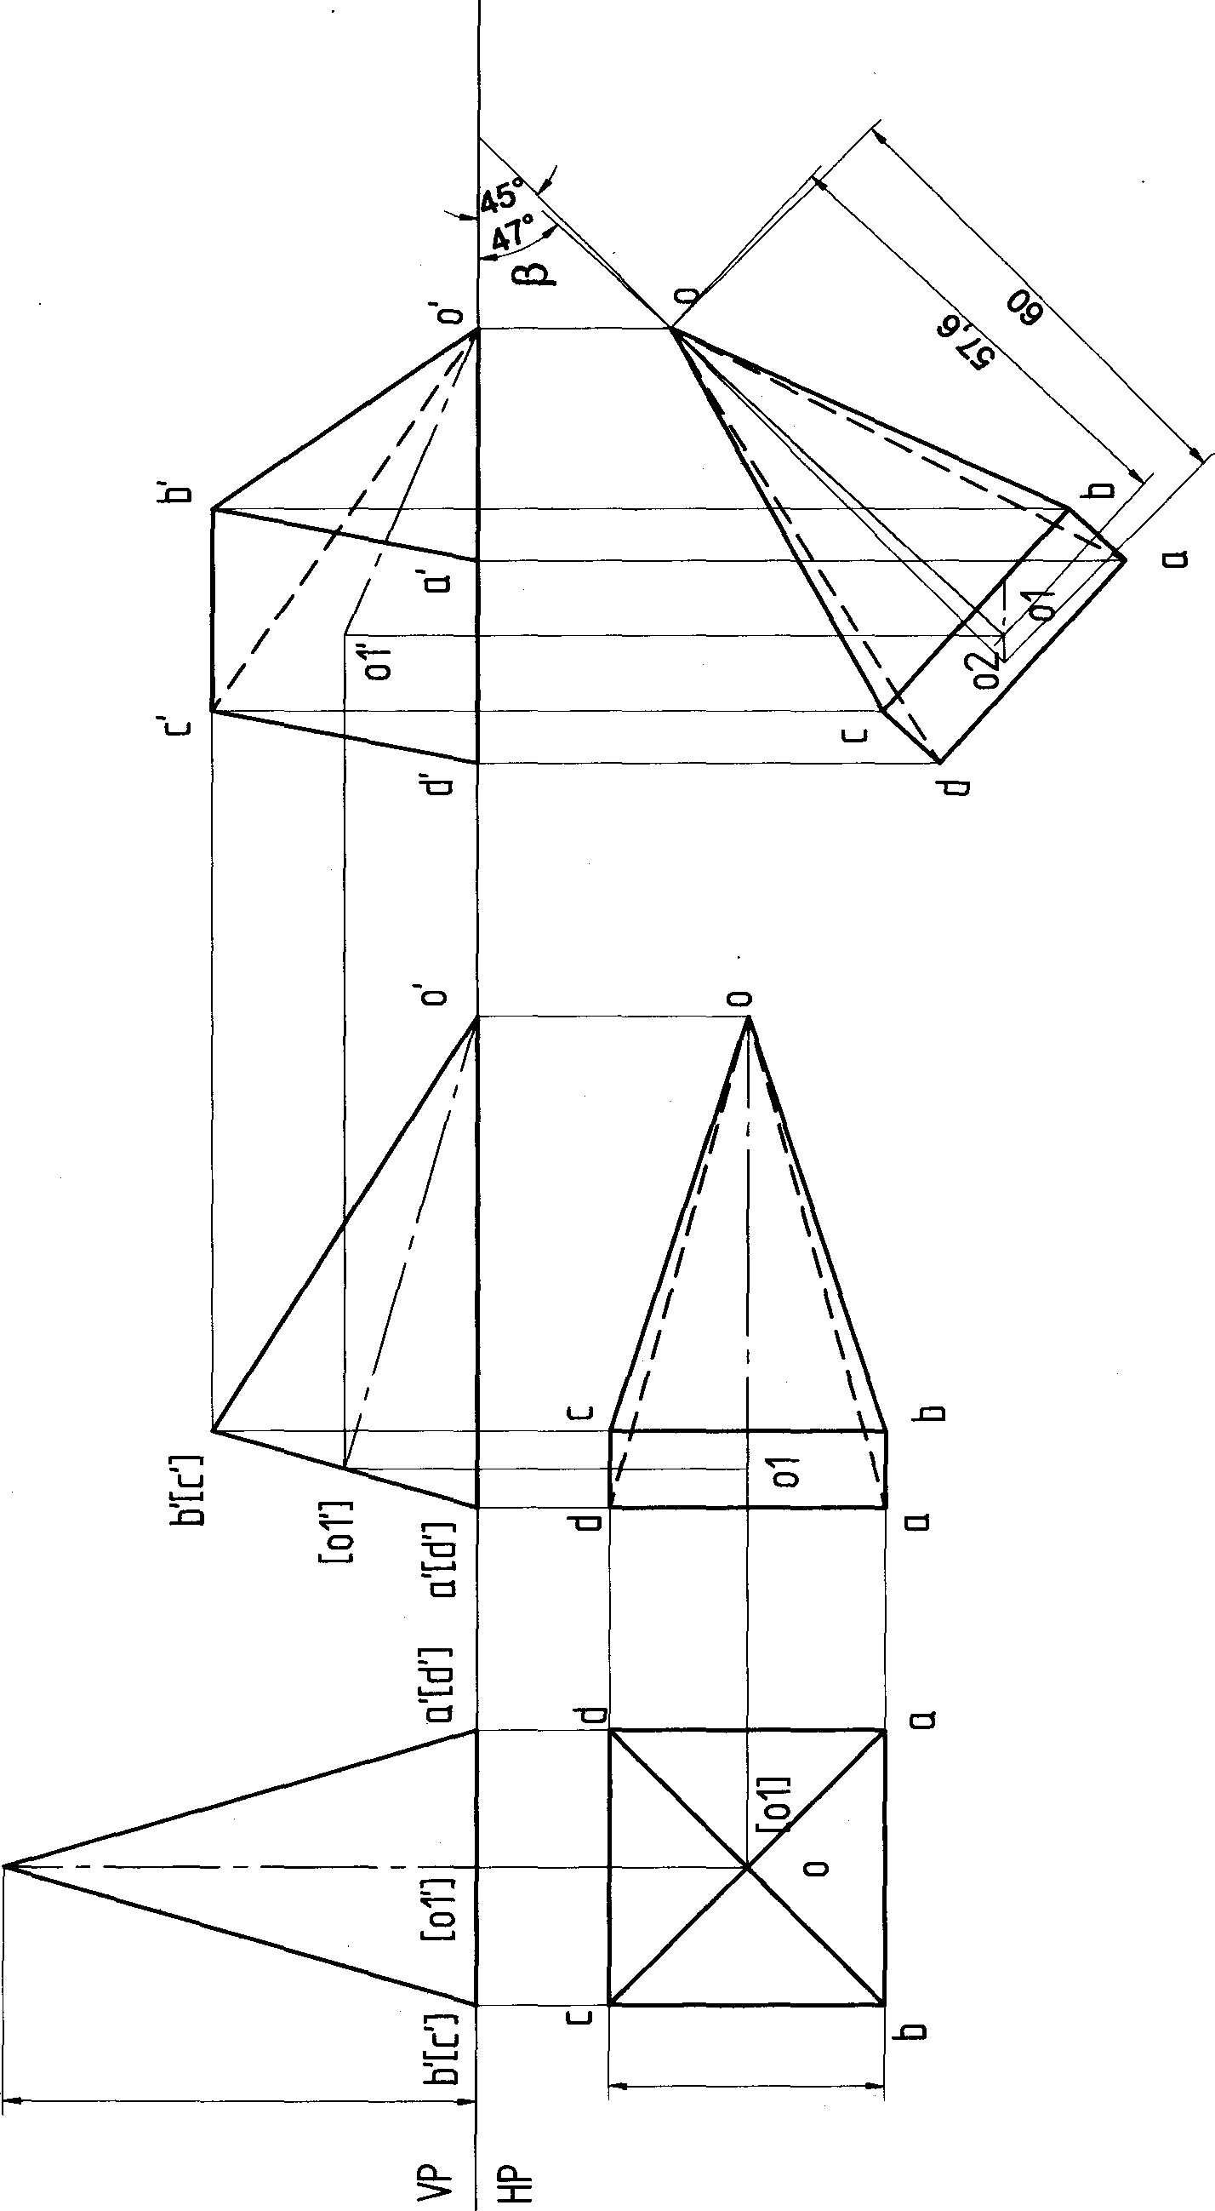

110

Problem 35 A pentagonal pyramid 25 mm sides of base and 50 mm axis length rests on HP on one of its slant edges. Draw the projections of the pyramid when the axis appears to be inclined to VP at 45°.

##### Solution

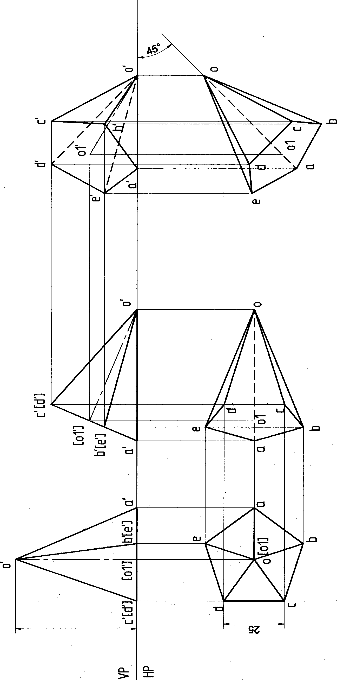

111

Problem 36 A pentagonal pyramid 25 *mm* sides of base and 50 mm axis length rests on HP on one of its slant edges. Draw the projections of the pyramid when the axis is inclined to VP at 45°.

##### Solution

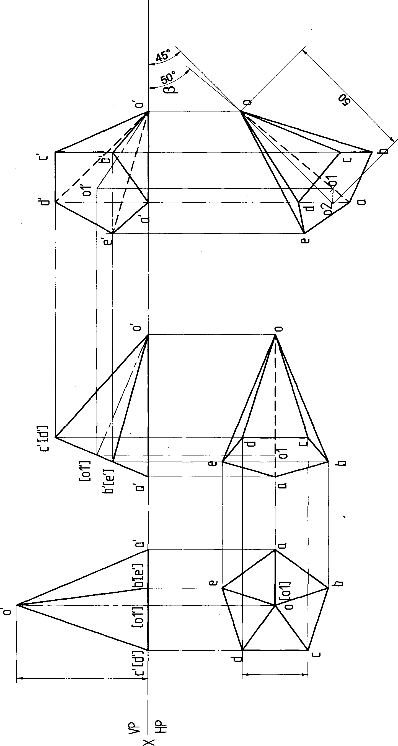0g sz

112

Problem 37 A pentagonal pyramid 25 mm sides of base and 50 mm axis length rests on HP on one of its slant triangular faces. Draw the projections of the pyramid when the axis appears to be inclined to VP at 45a.

##### Solution

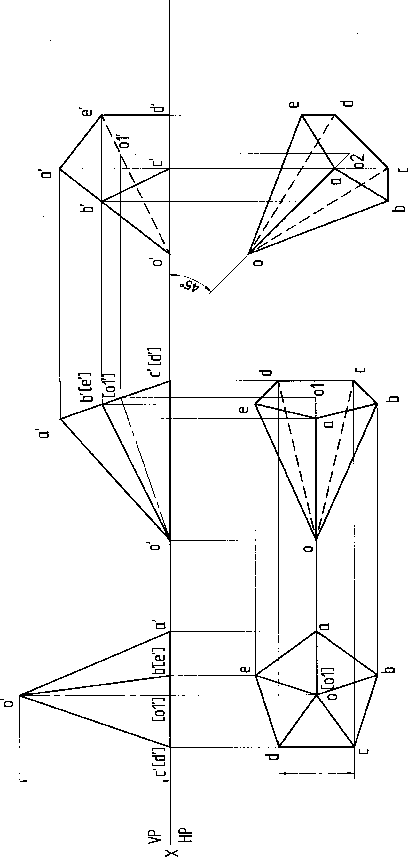 113

Problem 38 A pentagonal pyramid *25* mm sides of base and 50 mm axis length rests on HP on one of its slant triangular faces. Draw the projections of the pyramid when the axis is inclined to VP at 45°.

Solution

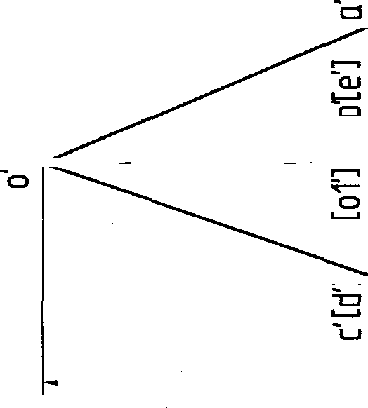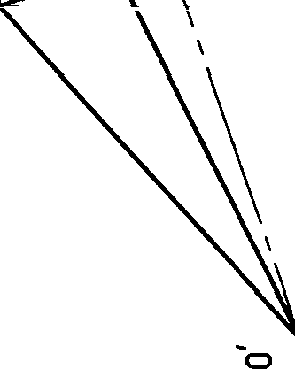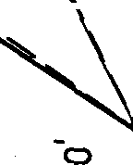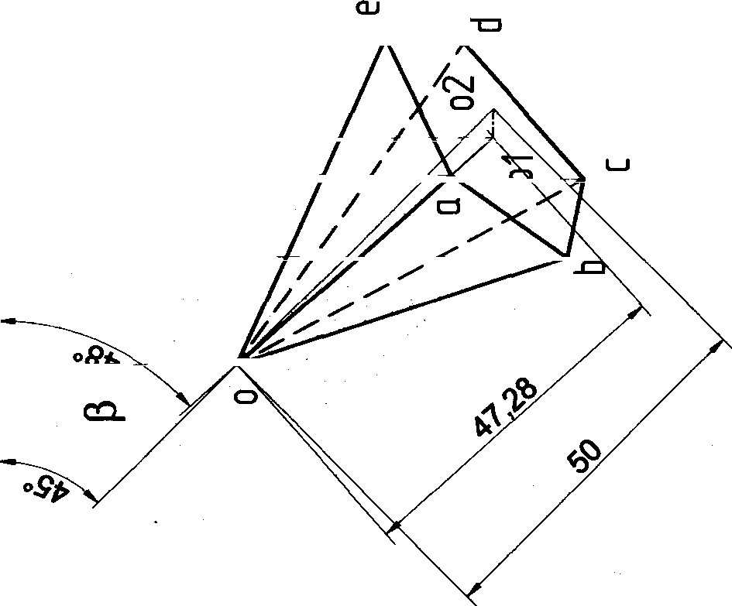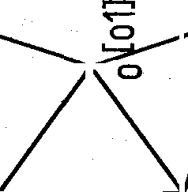

###### "

”\

"°

0

»

-cs

E’[ ğ

’]

0#

47 28

###### ru

0

114

Problem 39 A hexagonal pyramid 25 mm sides of base and 50 mm axis length rests on HP on one of its slant edges Draw the projections of the pyramid when the axis appears to be inclined to VP at 45*.

## Solution

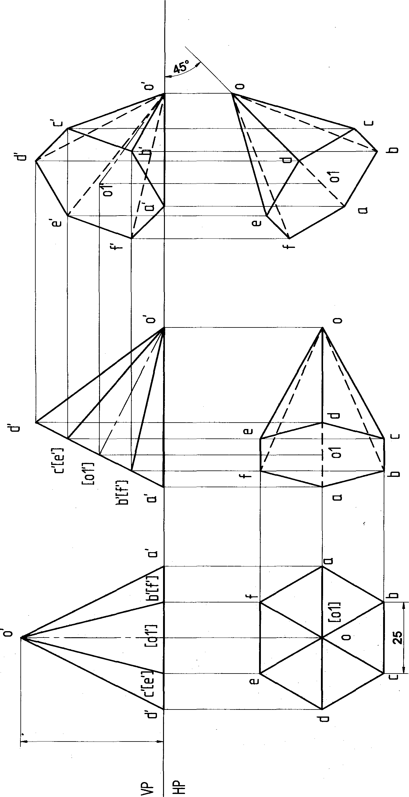

115

Problem 40 A hexagonal pyramid 25 mm sides of base and 50 mm axis length rests on HP on one of its slant edges

Draw the projections of the pyramid when the axis is inclined to VP at 45°.

##### Solution

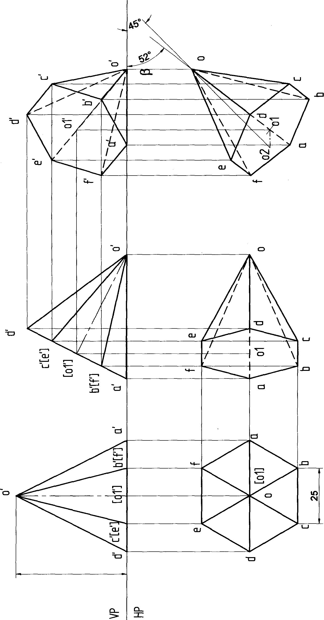

116

Problem 41 A hexagonal pyramid 25 mm sides of base and 50 mm axis length rests on HP on one of its slant triangular faces. Draw the projections of the pyramid when the axis appears to be inclined to VP at 45a.

Solution

,O

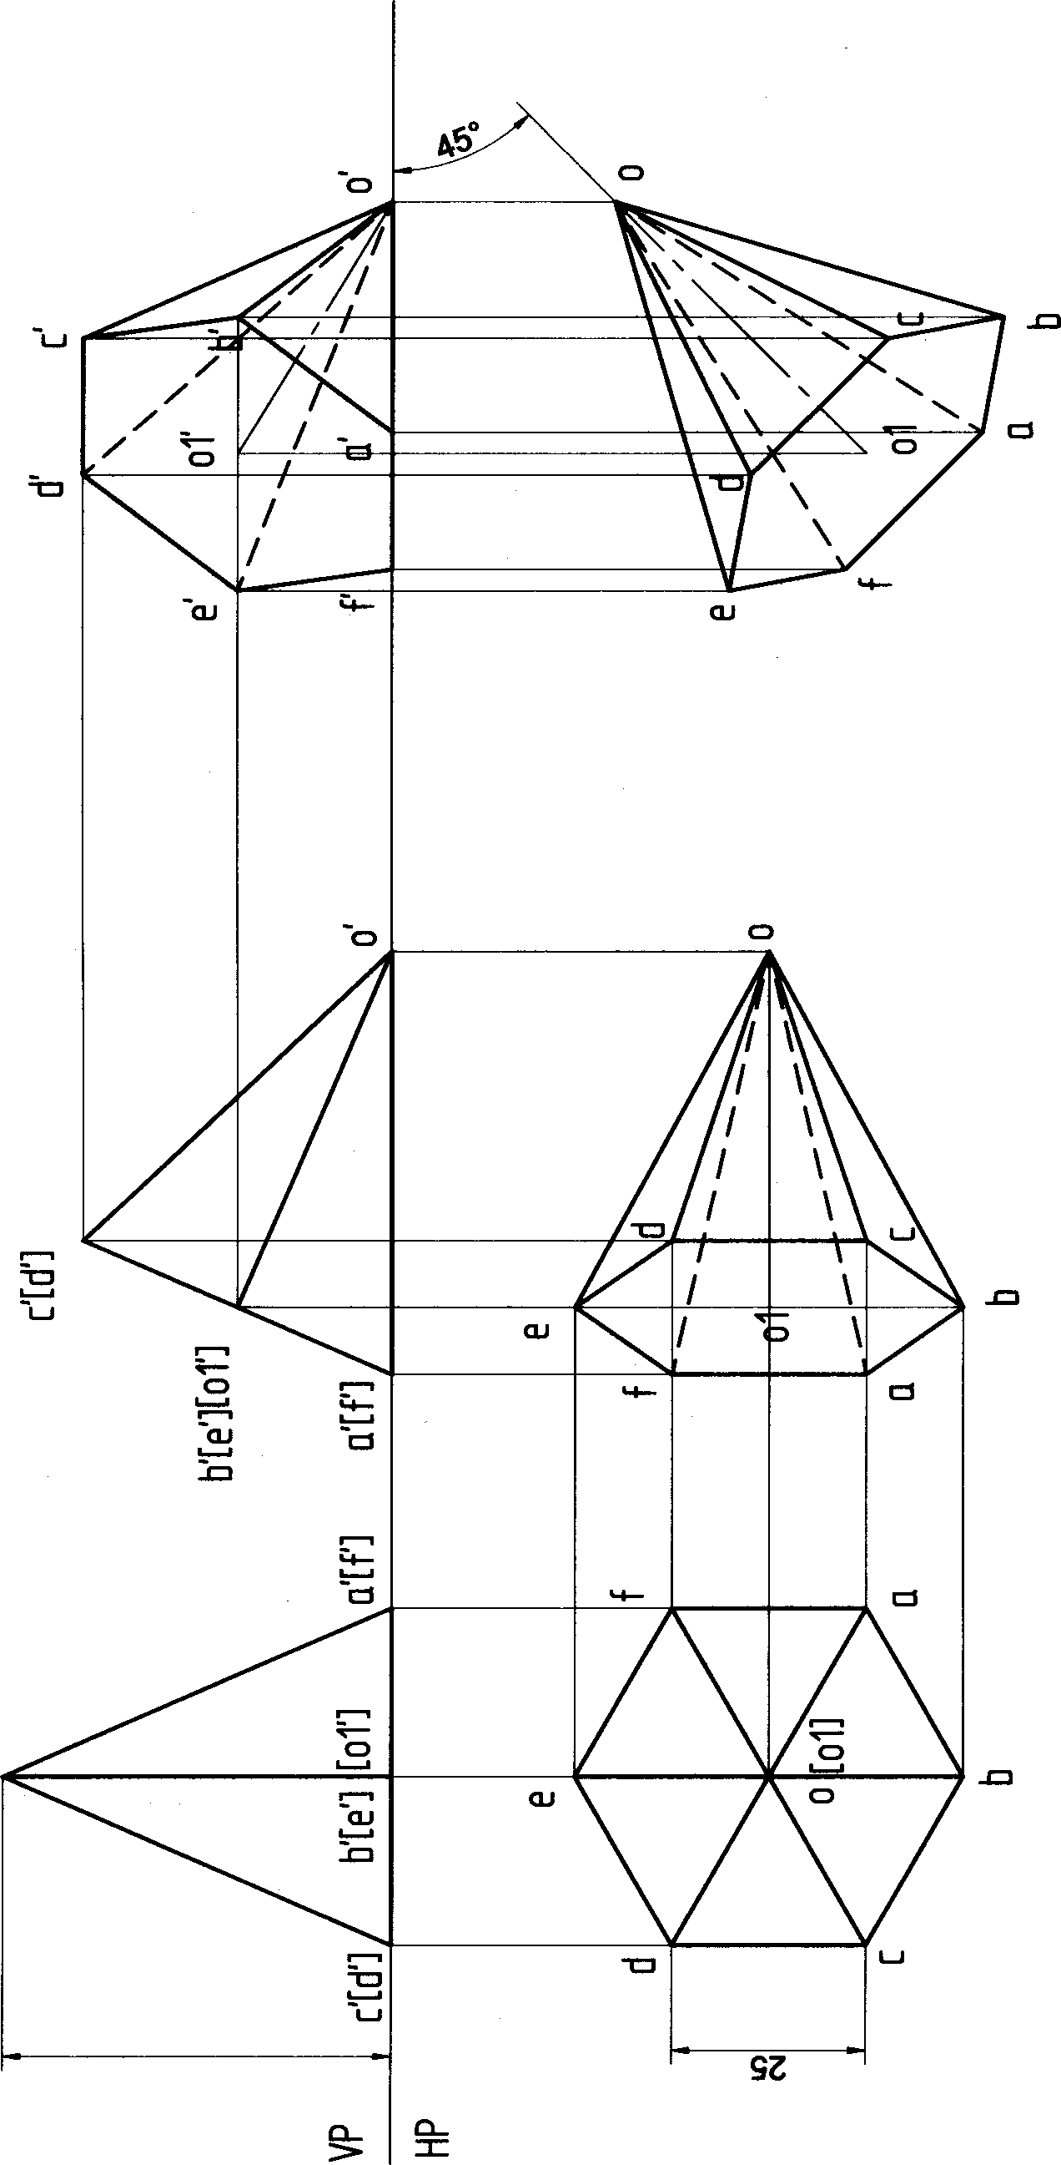

117

Problem 42 A hexagonal pyramid 25 mm sides of base and 50 mm axis length rests on HP on one of its slant

triangular faces. Draw the projections of the pyramid when the axis is inclined to VP at 45°.

###### Solution

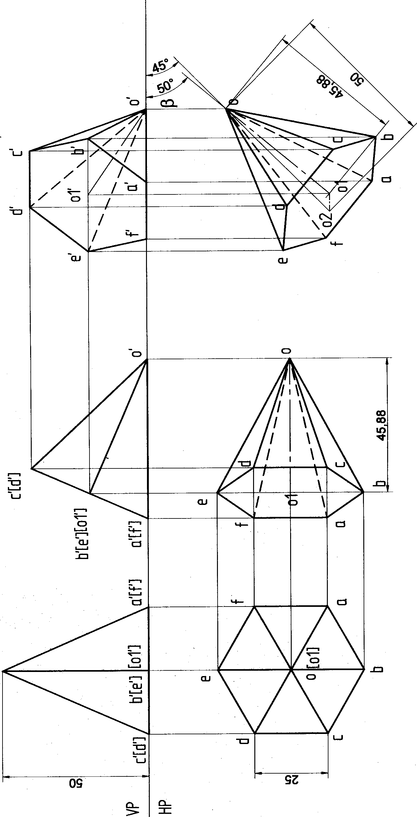

118

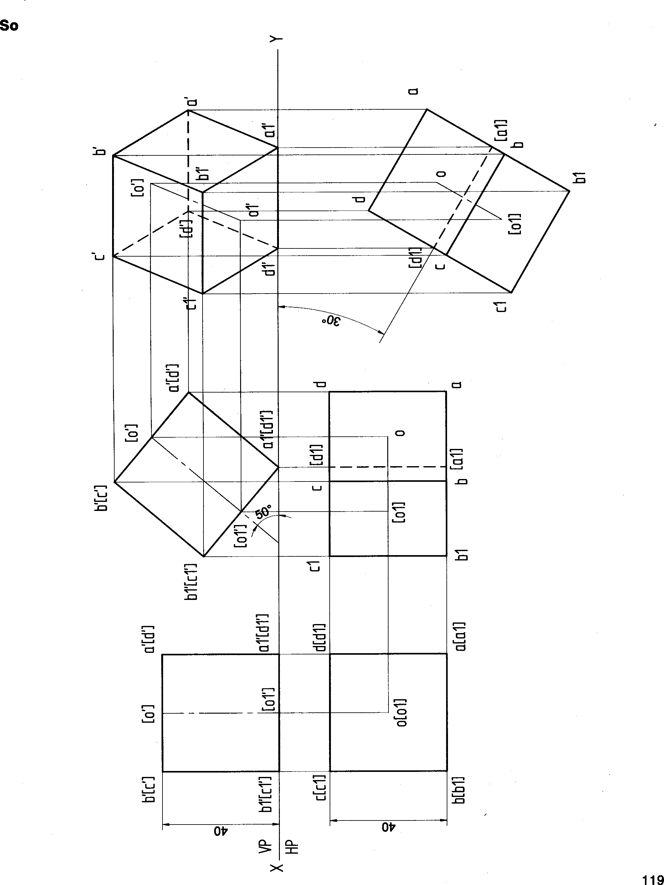Problem 43 A cube of 40 mm sides rests on HP on an edge which is inclined to VP at 30a. Draw the projections when the lateral square face containing the edge on which it rests makes an angle of 5¢P to HP.

#### lutlon

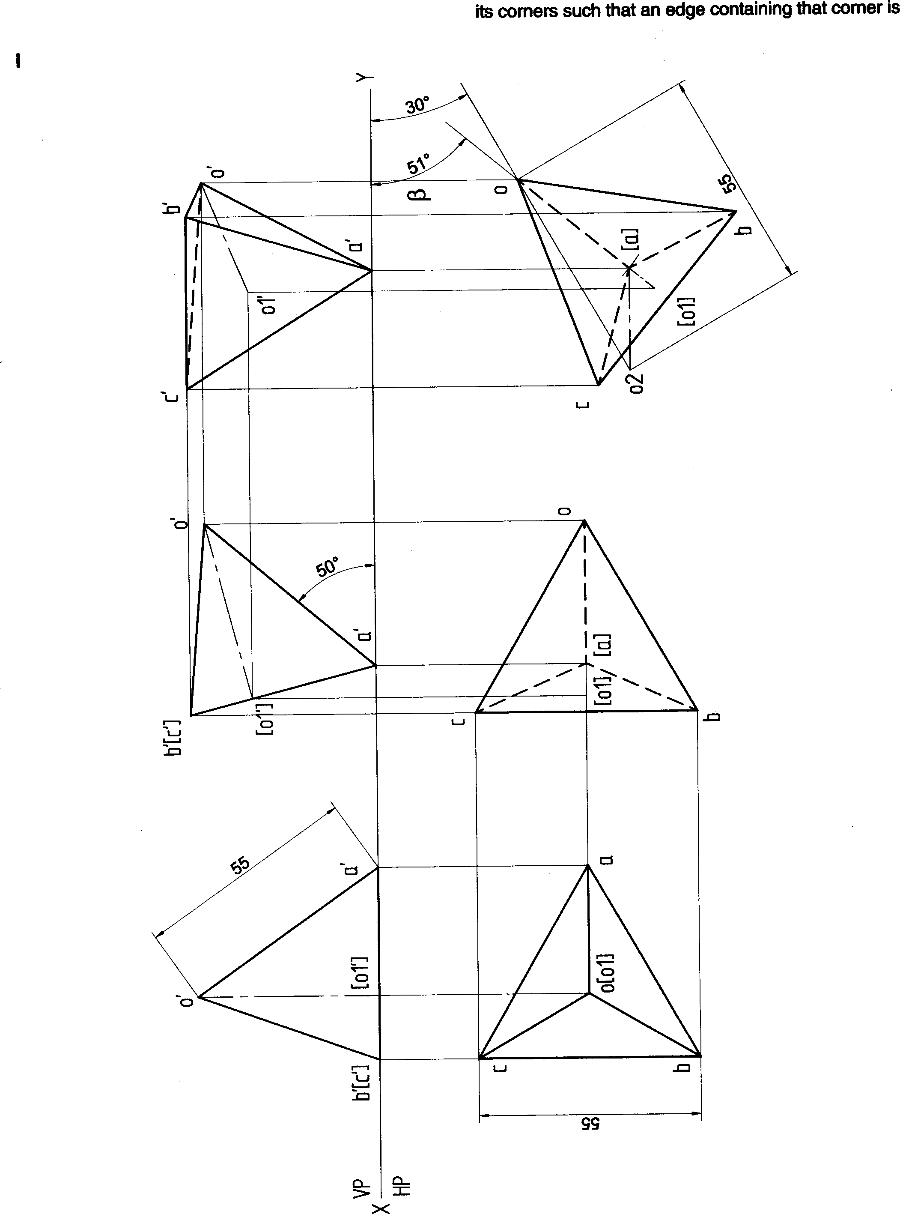



Problem 45 A cone of 50 mm base diameter and 60 mm axis length rests on HP on one of its generators. Draw its projections when the axis is inclined to VP at 30°.

##### Solution

09 05

121

Problem 46 A tetrahedron of sides 40 mm is resting on one of its sides on HP. This side is parallel to VP and 40 mm away from it. It is tilted about resting side such that the base containing this edge is inclined at 30° to HP. Draw the projections of the solid.

Solution

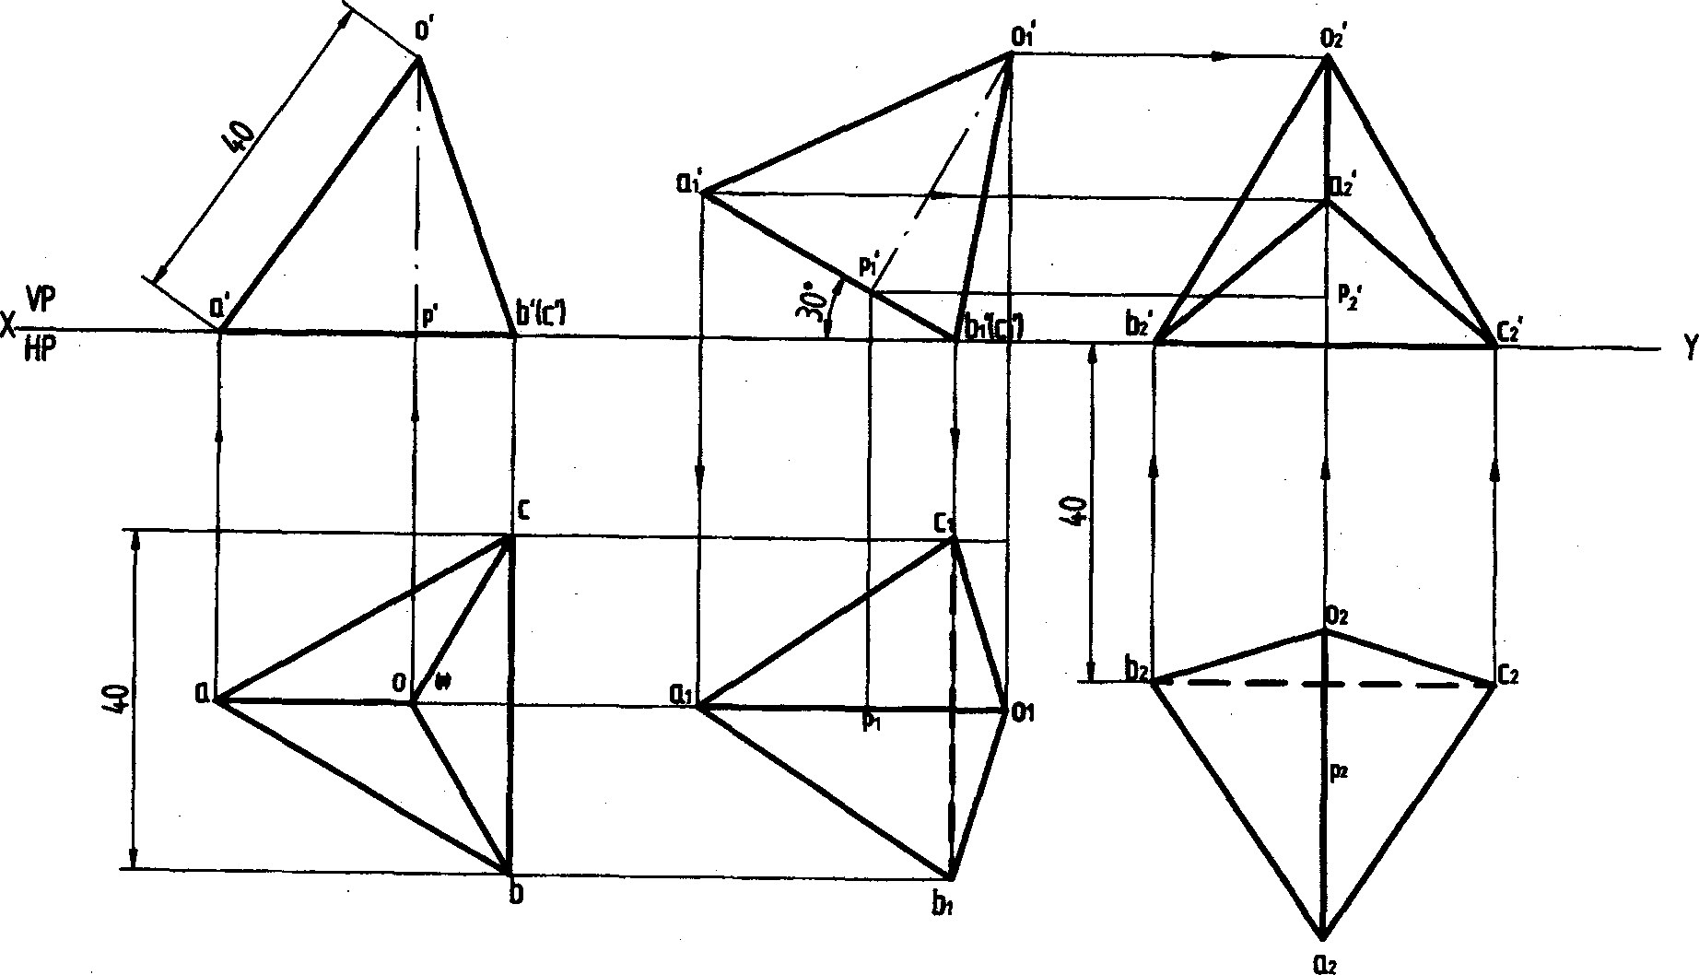

Problem 47 A Hexahedron of 30 mm sides is resting on one of its corners on HP such that one of its solid diagonals is perpendicular to VP. Draw the projections of the solid.

Solution

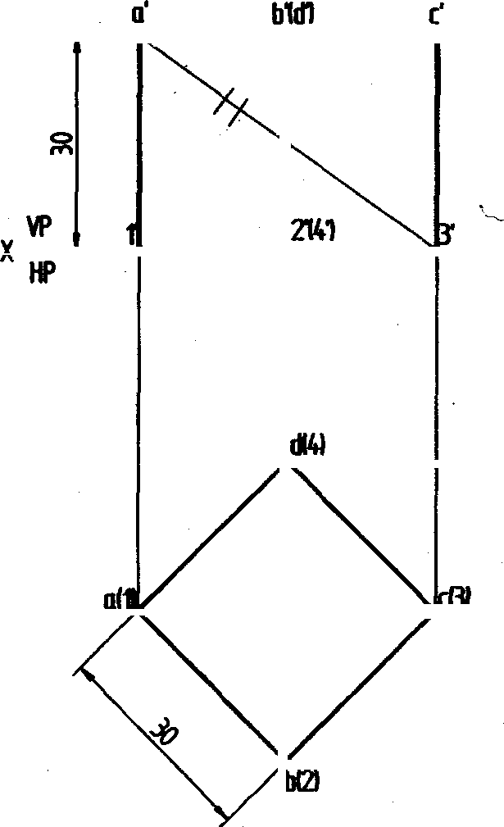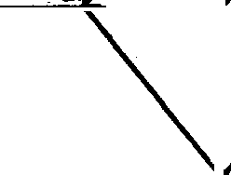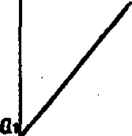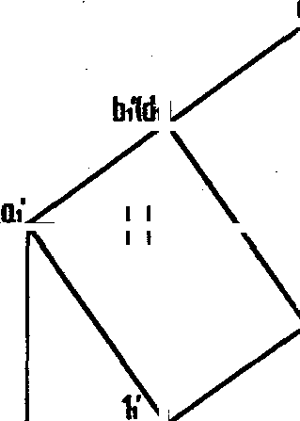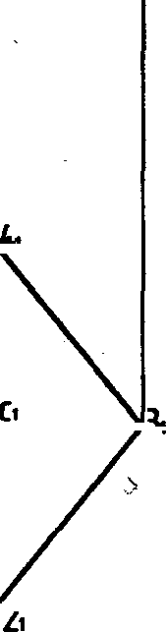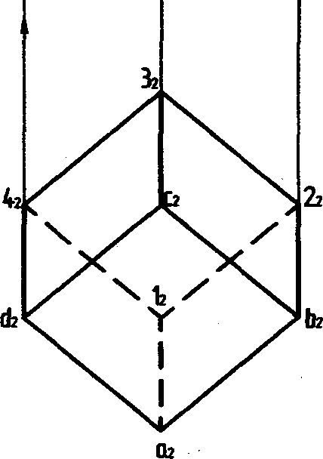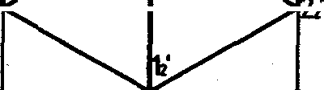

122

Problem 46 A pentagonal prism of base side 25 mm and height 50 mm is resting on HP on one of its base corners such that the top most edge is at a distance of 60 mm above HP. Draw its projections, when its top view of the axis is inclined at 450 to VP. Also, determine the inclination ot the longer edge of the prism to HP which contains the resting corner.

## Solution

123

ÑfõblDłfl 4Ñ Å gg+Bf9 fäł’f}țd Of băS6 6İdes 90 mr/j gnd h»‹eht 60 mm is suspęnded by a thregd tied ło one 9f the ‹ș9rß,9fî› ef its ğBęe. It i9 thaR țilted a‹Jsh thgt the eXİ6 mBk9a OR gnglę 4f 45’ wİth r6sPé0t la Ît›e V • Oenlłd9rinę łf›ø gpgh pf tqe seI!d to be nearer to tie obeary9r, draw the pr?jeętipne of the solid.

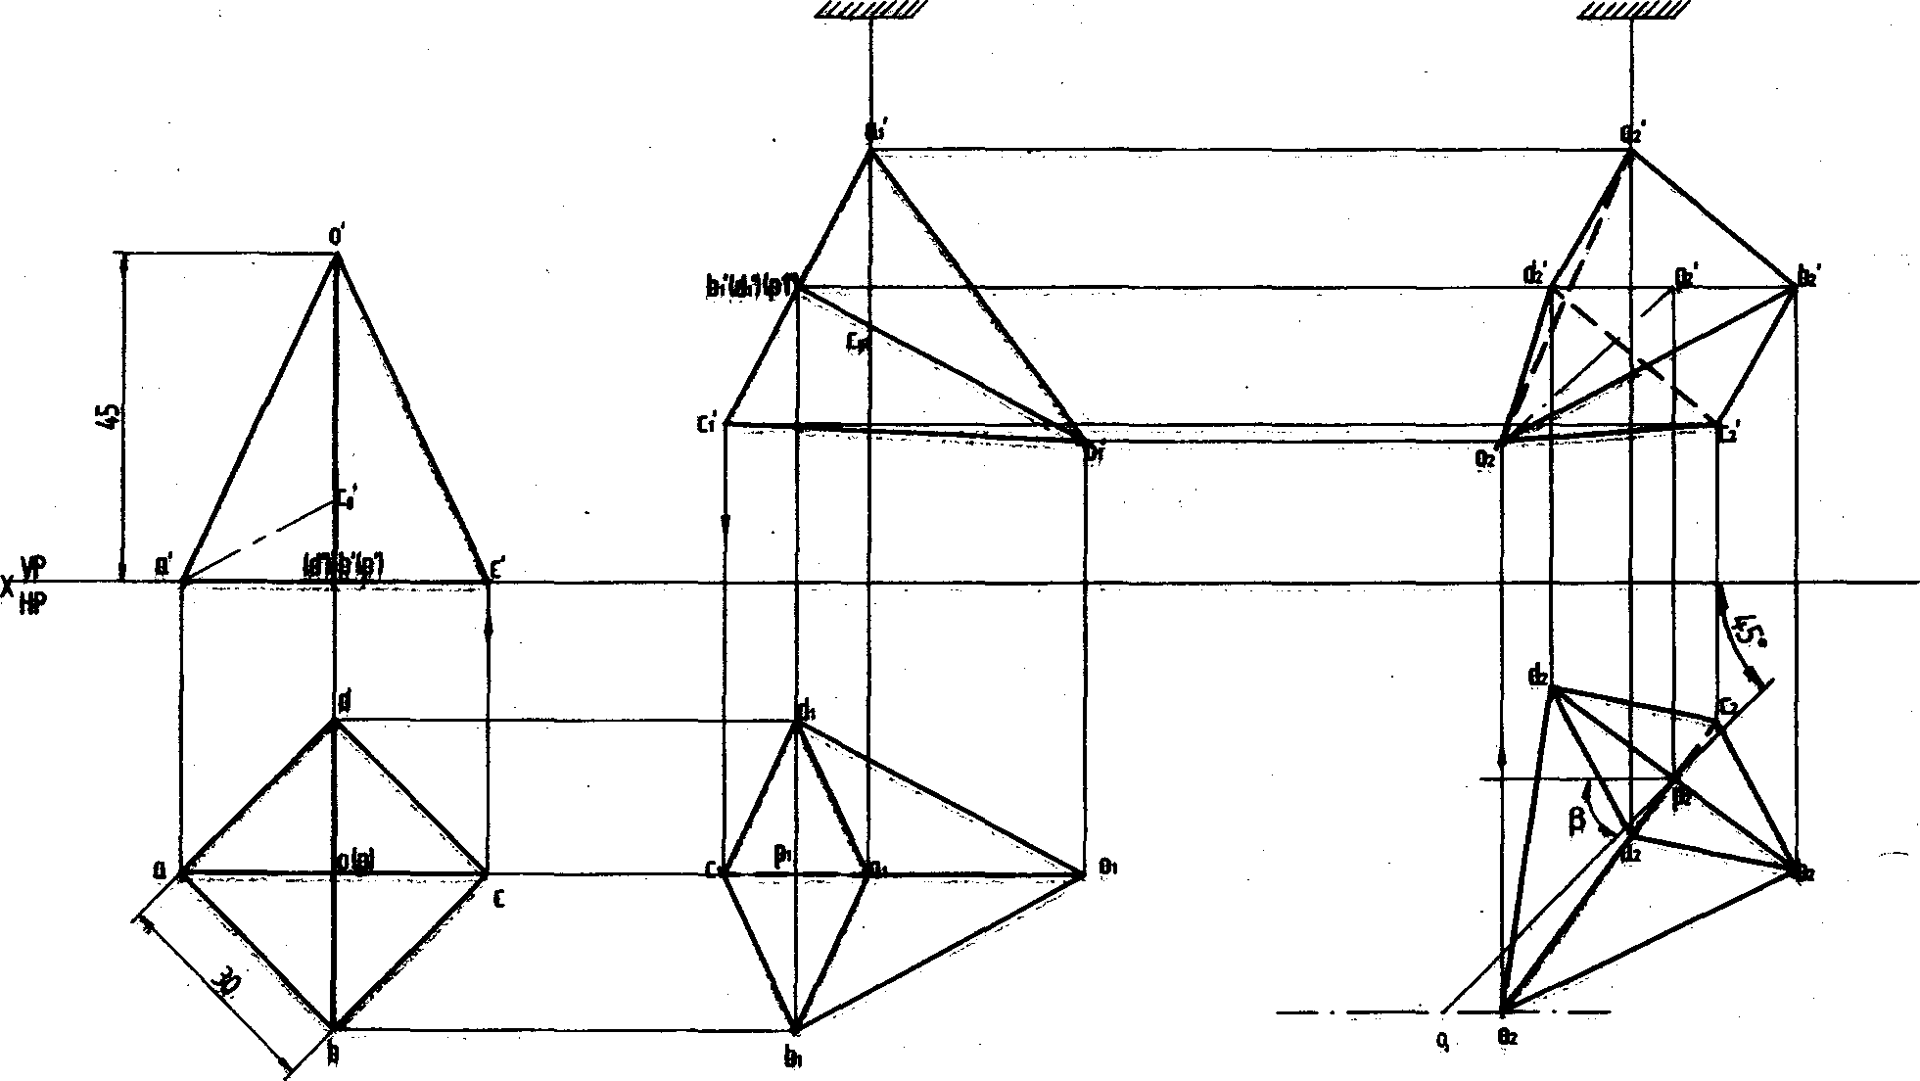

###### Prgbl0lg ț0 A ø.pne of basę ğią. 40 mm and axİş IeRgth 60 mm i» resting on HP on a point on the ciroum- fşrgpțp gț ¡țț ğaşø such thąt İll apex it at 40 mm above the HP arid Its top view of tRe gxis is inolined at 600 t9 VP. Brg\y (#g top gntł fr9nt views of the solid. Also, datørming th9 tfielinatiens of the axi9 when the ba8e

»æin 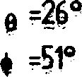

124